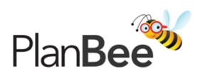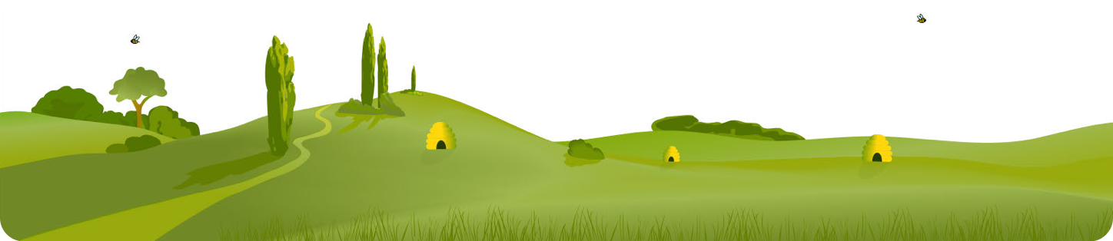The Maya : Cross-Curricular Topic
Geography
1 | Locate where the Maya lived on a world  map and the modern day countries and  cities that are there now.
2 | Use a variety of sources to explore the  physical geography of Mesoamerica.
3 | Explore what life is like for modern Mayan  people and compare this to the life of the  Maya in the 1st century.
• KS2 - locate the world’s countries, using maps to focus on Europe (including the location of Russia) and North and South America, concentrating on their environmental regions, key physical and human characteristics, countries, and major cities
• KS2 - understand geographical similarities and differences through the study
of human and physical geography of a region of the United Kingdom, a region in a European country, and a region within North or South America
• KS2 - describe and understand key aspects of physical geography, including:
climate zones, biomes and vegetation belts, rivers, mountains, volcanoes and earthquakes, and the water cycle
• KS2 - describe and understand key aspects of human geography, including:
types of settlement and land use, economic activity including trade links, and the distribution of natural resources including energy, food, minerals and water
• KS2 - use maps, atlases, globes and digital/computer mapping to locate
countries and describe features studied

History
1 | Investigate how and when Europeans encountered the Mayan civilisation.
2 | Explore how we know about the Mayan civilisation and their way of life.
3 | Explore how Mayan society was organised and how this compares to modern society.
4 | Find out about what the Maya believed in, including their religious rites and rituals.
5 | Use a variety of sources to piece together what life was like for the Maya.
6 | Exploring the achievements of the Maya including their number systems and  calendar.
7 | Investigate the reasons behind the decline of the Mayan civilisation.
• KS2 - a non-European society that provides contrasts with British history –
one study chosen from: early Islamic civilization, including a study of Baghdad c. AD 900; Mayan civilization c. AD 900; Benin (West Africa) c. AD 900-1300

The Maya
A KS2 cross-curricular topic for
Year 3 and 4
DT
1 | Design, make and evaluate a model of a Mayan  temple.
• KS2 - use research and develop design criteria to inform the design of innovative,
functional, appealing products that are fit for purpose, aimed at particular individuals or groups
• KS2 - generate, develop, model and communicate their ideas through discussion,
annotated sketches, cross-sectional and exploded diagrams, prototypes, pattern pieces and computer-aided design
• KS2 - select from and use a wider range of tools and equipment to perform practical
tasks [for example, cutting, shaping, joining and finishing], accurately
• KS2 - select from and use a wider range of materials and components, including
construction materials, textiles and ingredients, according to their functional properties and aesthetic qualities
• KS2 - evaluate their ideas and products against their own design criteria and consider the
views of others to improve their work
• KS2 - apply their understanding of how to strengthen, stiffen and reinforce more
complex structures

Art
1 | Explore the mask of Lord Pakal and recreate  Mayan masks.
2 | Use clay to recreate Mayan artefacts.
3 | Recreate the Bonampak murals using pastels  and 3D nets.
• KS2 - to improve their mastery of art and design techniques, including drawing with a
range of materials
• KS2 - to improve their mastery of art and design techniques, including painting with a
range of materials
• KS2 - to improve their mastery of art and design techniques, including sculpture with a
range of materials

PSHE
Explore the implications of the Spanish
1 conquest for the Mayan people.
Consider the concept of a hierarchy in the
2 context of Mayan society and modern
society.
Identify the areas of modern and Mayan
3 lifestyles which are healthy or unhealthy.

Copyright © PlanBee Resources Ltd 2018 www.planbee.com

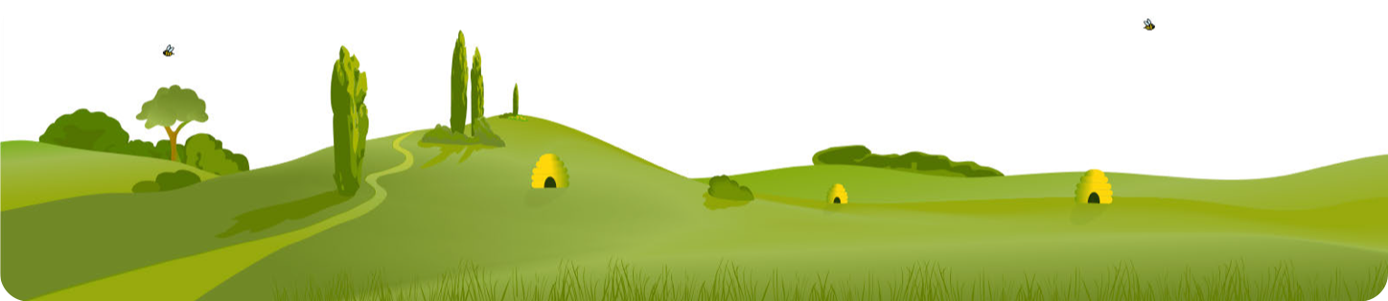The Maya English Science
Teacher’s Topic Planner
Maths

History Geography RE
7 Lessons 3 Lessons

Computing

Art
3 Lessons
DT
1 Lesson

Copyright © PlanBee Resources Ltd 2018 www.planbee.com

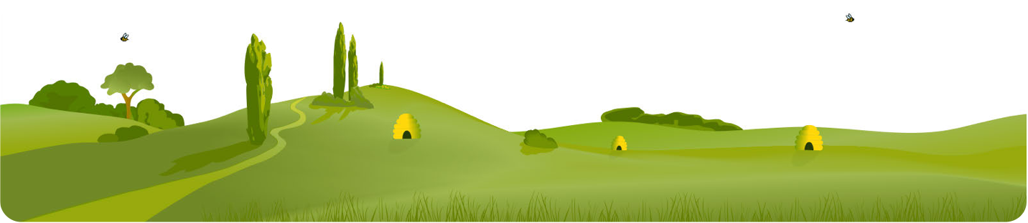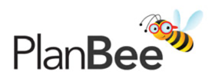The Maya : Cross-Curricular Topic : Year 3/4
Teacher’s notes:
Art

Geography

DT
PSHE

History

Copyright © PlanBee Resources Ltd 2018 www.planbee.com

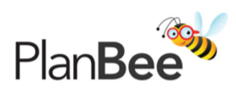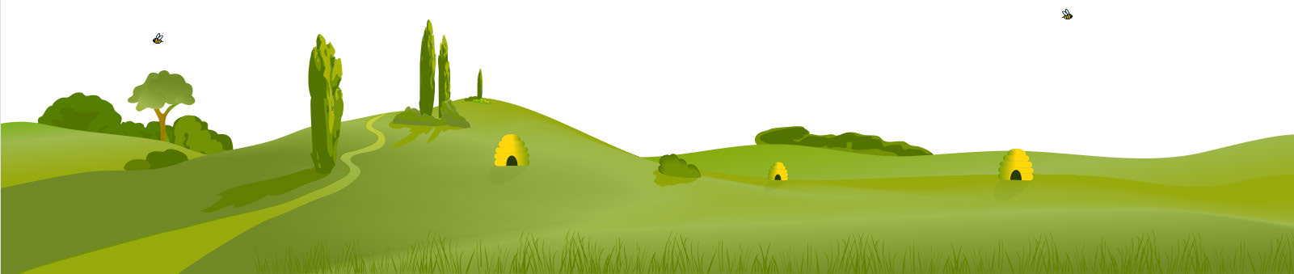The Maya : Cross-Curricular Topic : Year 3/4
 | HISTORY
 | Learning Objective | Overview | Assessment Questions | Resources
Lesson 1 | To explore where and when the remains of the Mayan ruins were discovered. | Children will find out about the Spanish conquistadors and their expeditions in Mesoamerica. They will look at  some of the Mayan temple ruins and generate questions that the conquistadors might have asked, as well as questions they would like to find the answers to themselves. | • Do children know where Mesoamerica is on a world map?  • Do children know how the Mayan ruins were discovered by  Europeans?  • Can children use images to raise questions? | • Slides  • Picture Cards  • Worksheets 1A/1B/1C  • Challenge Card (FSD? activity only)  • Costumes - optional (FSD? activity only)
Lesson 2 | To find out about how the Mayan civilisation developed over time. | Children will learn what an archaeologist does and look at how artefacts can help us find out about the Mayan civilisation. They will be given a brief overview of the Mayan civilisation and start to order events chronologically. | • Do children know how archaeologists use evidence to find out  about the past?  • Can children deduce facts about the Maya from archaeological  discoveries?  • Can children order events chronologically? | • Slides  • Worksheets 2A/2B/2C/2D  • Sentence Cards A/B  • Artefact Cards  • Timeline Cards A/B (FSD? activity only)  • Timeline Sheet (FSD? activity only)
Lesson 3 | To find out about the city states of the Maya and how society was organised. | Children will think about how our society is run and who makes our decisions before comparing this with how Mayan society was structured. They will find out about different groups of Mayan people from kings and nobles to slaves and farmers, as well as how Mayans lived in various independent city states. | • Do children know that the Mayan civilisation was organised in  city states?  • Do children know that Mayan society was organised in a  pyramid system with high and low ranks?  • Can children describe the roles of different members of Mayan  society? | • Slides  • Worksheets 3A/3B/3C/3D/3E  • Sentence Cards  • Mayan City States Map (FSD? activity only)
Lesson 4 | To find out about Mayan religion and beliefs. | Children will find out what the Maya believed and how this affected their daily lives. They will explore some of  the Mayan gods and what they demanded from the Mayan people, including bloodletting and human sacrifice, as well as learning about the role of priests and beliefs about the afterlife. | • Do children know that the Maya worshipped many different  gods?  • Do children know some of the ways in which Maya worshipped?  • Can children describe how religion affected people’s daily lives? | • Slides  • Worksheets 4A/4B/4C/4D/4E  • Information Sheet A/B  • Books, access to internet, etc.  • Story Sheet
Lesson 5 | To find out about everyday life for the Mayan people. | Children will generate questions surrounding the everyday lives of ordinary Mayan people. They will use a variety of different sources of information to find answers to their questions and present their findings in a variety of ways. | • Can children generate questions?  • Can children use a variety of sources to answer questions?  • Can children describe what daily life was like for the Maya? | • Slides  • Worksheets 5A/5B/5C/5D  • Information Sheet  • Picture Cards  • Question Cards  • Books, access to internet, etc.  • Challenge Cards (FSD? activity only)
Lesson 6 | To explore Mayan writing and calendars. | Children will find out about some of the major achievements of the Maya, specifically a complete writing and number system, and the development of calendars. They will consider the importance of writing from the Maya in helping historians find out about the past. | • Do children know that the Maya developed their own writing  system?  • Do children know that we can learn a lot about the Maya from  the writing they left behind?  • Do children know that the Maya developed a calendar based on  astronomical observation? | • Slides  • Worksheets 6A/6B/6C  • Information Sheet A  • Game Cards  • Information Sheet B (FSD? activity only)  • Picture Cards (FSD? activity only)  • Calendar Template (FSD? activity only)  • Month Cards (FSD? activity only)
Lesson 7 | To find out about the decline of the Mayan civilisation. | Children will look at evidence for battles between city states and consider some of the reasons for the decline of the Mayan civilisation. They will think about what could have caused Maya to abandon their major cities. They will discover that the Maya didn’t disappear completely and that Mayan people still live in the area today. | • Do children know that Mayan city states often recorded battles  on stelae?  • Do children know that the Mayan civilisation declined c.900  AD?  • Can children offer suggestions for why a civilisation may  decline? | • Slides  • Cause Cards  • Worksheets 7A/7B/7C/7D  • End of Unit Quiz

Copyright © PlanBee Resources Ltd 2018 www.planbee.com

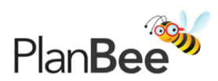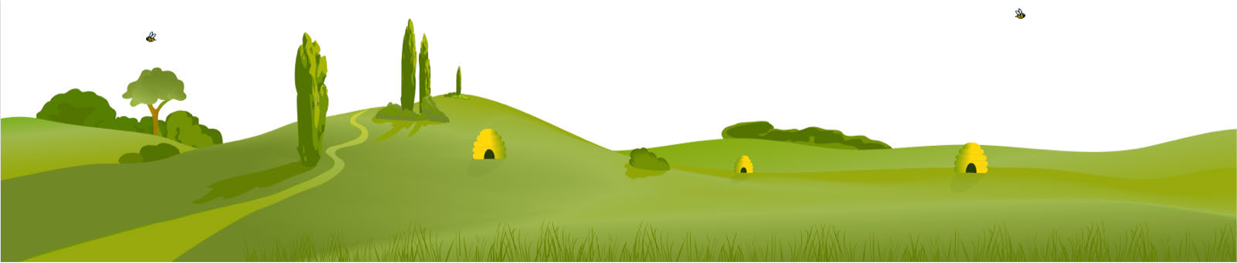The Maya : Cross-Curricular Topic : Year 3/4
 | GEOGRAPHY
 | Learning Objective | Overview | Assessment Questions | Resources
Lesson 1 | To find out where the Maya lived. | Children will begin by exploring which continent the Mayan civilisation was found on. They zoom into a smaller map of Central America and are challenged to find the names of the modern countries that the Mayans’ land covered. They are introduced to several different kinds of maps including  topographical, road and political and the uses of each kind. They must choose the most suitable for finding the information they need. | • Can children identify where the Maya lived on a  world map?  • Do children know that the Maya lived in the  continent of North America?  • Can children use maps to identify the modern-day  countries in which the Maya lived? | • Slides  • Worksheets 1A/1B/1C/1D  • Political Map  • Atlases/online maps  • Mayan Map (FSD? activity only)
Lesson 2 | To compare the physical geography of Mesoamerica and the UK. | Children are challenged to compare the geography of the UK and Mesoamerica using data and various other sources of information. In particular they will investigate the average monthly temperatures of the two locations as well as comparing the average monthly precipitation. They discuss their predictions before researching the information and using graphs to present and interpret their findings. | • Can children locate the area in which the Maya  lived on a map?  • Can children use a variety of sources to find out  about the physical geography of Mesoamerica?  • Can children compare Mesoamerica and the UK? | • Slides  • Worksheets 2A/2B/2C/2D/2E  • Fact Cards  • Information Sheet
Lesson 3 | To find out about the way of life of modern Mayan people. | Children investigate how modern day Mayan people’s lives have been affected by the events in the past. They will explore how the Spanish conquistadors influenced many of their religious beliefs and languages but also how modern Mayan people have also kept aspects of their traditions and culture. | • Do children know that Maya still live in Mexico,  Belize and Guatemala today?  • Can children use a variety of sources of information  to find out about what life is like for modern Maya?  • Can children compare the way of life of ancient and  modern Maya? | • Slides  • Worksheets 3A/3B/3C/3D  • Picture Cards  • Information Sheet

Copyright © PlanBee Resources Ltd 2018 www.planbee.com

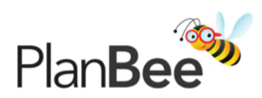The Maya : Cross-Curricular Topic : Year 3/4
 | ART
 | Learning Objective | Overview | Assessment Questions | Resources
Lesson 1 | To recreate a Mayan mask. | Children explore the historical use of masks in Mayan society and who wore them. They will investigate the discovery of Lord Pakal’s tomb and the mask and jewellery he wore to help him become a god in the afterlife. The children are presented with several different ways to recreate a Mayan mask and are challenged to make one of their own. | • Do children know some of the ways in which  Mayans used and made masks?  • Can children gather ideas from art in the past to  use in their own artwork?  • Can children use a variety of techniques to create a  Mayan mask? | • Slides  • Worksheets 1A/1B/1C  • Mask Template  • Blue and green paper  • Balloons  • Newspaper strips  • Glue and water  • Black paint  • Elastic or ribbon
Lesson 2 | To use clay to recreate Mayan art and artefacts. | Children analyse different Mayan artefacts to  discuss what they were made from, how they were made and what they could have been used for. The children will discuss the materials and colours used to decorate these artefacts. After viewing these the children are challenged to make their own Mayan tile or stele from clay. | • Can children comment on various aspects of Mayan  art?  • Can children design a piece of Mayan artwork,  using images to influence their design?  • Can children work with clay to produce a piece of  Mayan artwork? | • Slides  • Worksheets 2A/2B/2C  • Picture Cards  • Help Sheet (FSD? activity only)  • Clay and clay tools  • Paint
Lesson 3 | To explore and recreate the Bonampak murals. | Children explore the images of the Bonampak murals to analyse the colours used. They look at the way the murals were fresco paintings and think about the different images and events the murals are depicting. The children then use viewfinders to recreate parts of the murals on their own. | • Do children understand that art can help us learn  about people and societies in the past?  • Can children explore Mayan art and state what they  think and feel about it?  • Can children recreate the Bonampak murals using  appropriate techniques? | • Slides  • Picture Cards  • Viewfinders  • Black paper  • Pastels  • Bonampak Template (FSD? activity only)  • Help Sheet (FSD? activity only)

Copyright © PlanBee Resources Ltd 2018 www.planbee.com

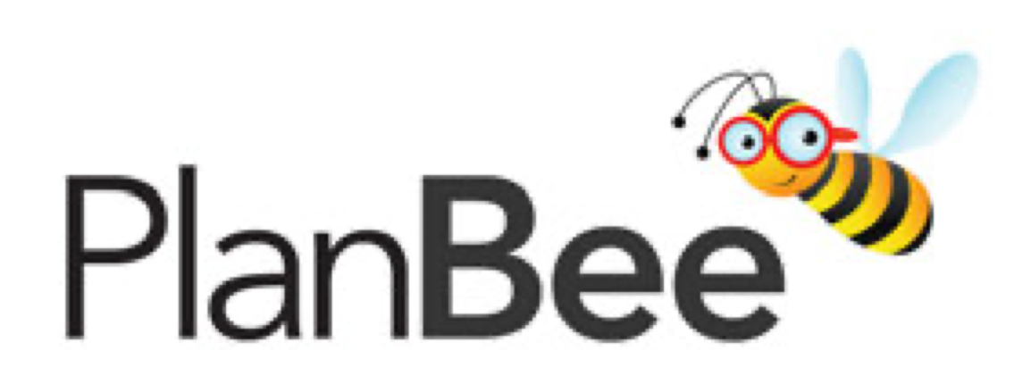The Maya : Cross-Curricular Topic : Year 3/4
 | PSHE
 | Learning Objective | Overview | Assessment Questions | Resources
Lesson 1 | To consider the effects and implications of the  Spanish invasion of Mayan lands. | Children investigate the effects that the arrival of the Spanish conquistadors had on the Mayan society. They will discuss the good and bad things that the Spanish introduced to the Mayans and the implications that this may have had for the Mayan people. | • Can children identify with the experiences of  different groups of people?  • Can children consider and discuss different  opinions openly?  • Can children make their own decisions about what  they believe and give reasons for their choices? | • Slides  • Worksheets 1A/1B/1C  • Sentence Cards  • Debate Cards (FSD? activity only)
Lesson 2 | To explore the concept of hierarchy and relate this to daily life. | Children reflect on the hierarchies of Mayan culture and our own culture. They compare the democratic nature of the UK’s parliament and the ways kings were chosen in Mayan civilisations. They are challenged to think about what a good leader does and how the rules and laws that are made should be to keep people safe and happy. | • Do children know what a hierarchy is?  • Can children describe different hierarchies we have  in our society?  • Do children understand that rulers and leaders have  a special responsibility? | • Slides  • Worksheets 2A/2B/2C/2D  • Mayan Madness Board Game (FSD? activity only)  • Dice and counters (FSD? activity only)
Lesson 3 | To explore whether the Maya had a healthy lifestyle. | Children reflect on the active lifestyles of the Mayan people and how this compares to their own lifestyle. In particular they think about how the foods that the Maya ate were fresh and unprocessed. The children read about the lives of Mayan people and modern people and compare their lifestyles. | • Do children understand what is meant by the term  ‘healthy lifestyle’?  • Can children describe various aspects of a healthy  lifestyle, including diet and exercise?  • Can children identify aspects of modern lifestyles  that are unhealthy and suggest alternatives? | • Slides  • Worksheets 3A/3B/3C/3D  • Character Sheet A/B  • Foods for tasting (FSD? activity only)  • Plates, forks, etc. (FSD? activity only)

 | DT
 | Learning Objective | Overview | Assessment Questions | Resources
Lesson 1 | To be able to design, make and evaluate a model of a Mayan temple. | Children investigate the structure of a Mayan temple and think about what they could use  to create a model of it. They are shown different ways to get the general shape of the  temple but must think about how to strengthen and decorate their temples as well as including the staircase to the top. | • Can children choose appropriate materials, tools  and techniques for their design?  • Can children assemble and join a variety of  materials ensuring the structure is sturdy?  • Can children evaluate their finished products and  say what they think and feel about them? | • Slides  • Worksheets 1A/1B/1C/1D/1E/1F  • Temple Templates (FSD? activity only)  • Variety of materials and tools, e.g. cardboard, paper, corrugated card, lolly sticks, art straws, paint, glue,  scissors, craft knives, etc.

Copyright © PlanBee Resources Ltd 2018 www.planbee.com

