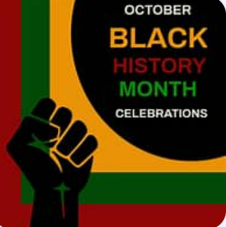
Black History Month October 2025 - Homework-KS2
This Black History Month 2025 we want to embrace the theme ‘Standing Firm in Power and Pride’.
It’s time to take control of our stories, celebrate our heritage and ensure our voices are heard.
 | Be a Writer | Be a Reader and a good listener | Be an Artist
In the UK, Black History Month falls in October each year and is a great time to learn about and celebrate Black history and heritage. However, Black history can, and should, be recognised and celebrated all year round.  Children should choose a minimum of one task per section or more if they wish.  Value stamps will be awarded upon completion of their projects  Have Fun! | A Research Project – Benjamin Zephaniah?  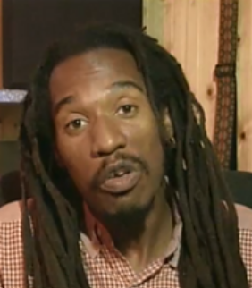  https://www.bbc.co.uk/newsround/articles/cm2z9lz3kpgo  https://www.bbc.co.uk/newsround/67665196  Present your researched information in the form of a report, a fact file, a poster or a poem.  https://www.bbc.co.uk/bitesize/topics/zxwqtfr/watch/zmxjpv4 | Black History Month Explained – Newsround (listen)  Why is it important to me?  Black History Month: Why it's important to me - BBC Newsround | Design and create a picture that reflects the theme of ‘Standing Firm in Power and Pride’  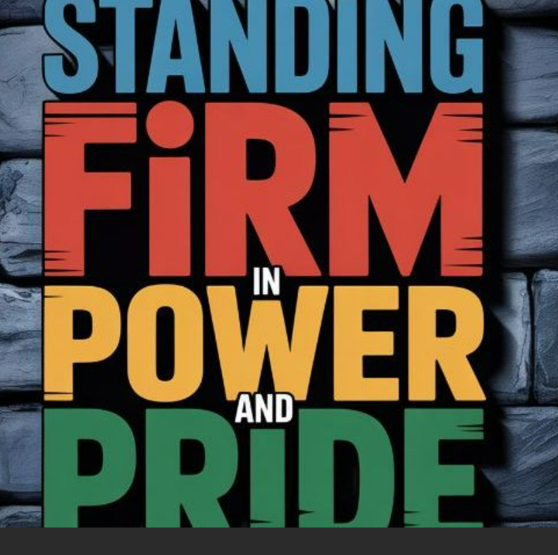
 | Read a book by an inspirational black or ethnic minority author and then…  Interview a character  Write down questions that you would like to ask a character if you had a chance to meet them  OR  Create your own character to join a character from the story that you have read. The new character could even be YOU!  Possible authors… Malorie Blackman, | Diversity and Parliament: Why is it important to celebrate Black History Month?  https://youtu.be/dSfUfuXxpwI?t=12  (listen)  Read about the life of a current inspirational black person. | Create a collage or painting that relates ‘Black History’ to our ‘Human Rights’.  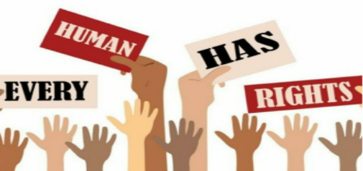
 | Listen to …  Malorie Blackman: Mary Seacole was 'way ahead of her time' - BBC Newsround  Present researched information about Mary Seacole in the form of a report, a quiz, a fact file or a poster. | You may know the story of Rosa Parkes, but have you heard of the …  story of Bristol Bus Boycotts in England? (listen)  https://youtu.be/uSyzaXXKUaQ  Remembering the first black bus driver in Bristol.  https://youtu.be/Nht6pyQFQ40 | 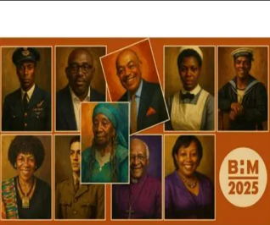  Using collage, paints, crayons or colour pencils create a piece of art that relates to a chosen inspirational ‘Black British or Ethnic Minority figure’.

