This Black History Month 2024 we want to embrace the theme ‘Reclaiming Narratives. It’s time to take control of our stories celebrate our heritage and ensure our voices are heard.
 | Be a Writer | Be a Reader and a good listener | Be an Artist
In the UK, Black History Month falls in October each year and is a great time to learn about and celebrate Black history and heritage. However, Black history can, and should, be recognised and celebrated all year round.  Children should choose a minimum of one task per section or more if they wish.  Value stamps will be awarded upon completion of their projects.  Have Fun! | Did you Know? – Create a poster for a story.  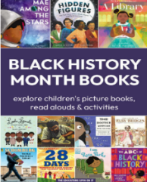  Possible authors –  Floella Benjamin,  Matthew Cherry  Mo Farah  Nathan Byron | Black History Month Explained – CBeebies (listen)  CBeebies | Let's talk about Black History (youtube.com) | Design and create a picture that reflects the theme of ‘Reclaiming Narratives’.  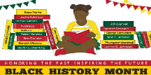
 | Read a book by an inspirational black author  Create your own character to join a character from the story that you have read. The new character could even be YOU! | https://www.youtube.com/watch?v=_hlgFwzQbrs  Listen to the narrative from Princess K about real life past black heroes.  Read about the life of a past or current inspirational black person. | Create a diversity picture using different people and cultures and colours. Use different skin tones.  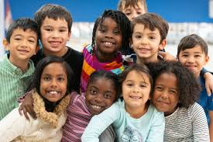
 | 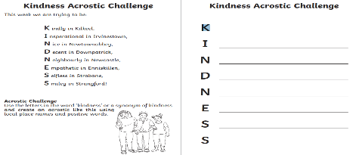  Research a famous black author.  Possible authors –  Floella Benjamin,  Matthew Cherry  Mo Farah  Nathan Byron  Use the information found to write an acrostic poem.  e.g. | Rosa Parks was an important part of Black History.  Listen to this story and think about:  https://www.youtube.com/watch?v=jFlm-GtsUkE  -Who was Rosa Parks?  -What important thing did she do?  -What change has been created because of her?  -How has it impacted people today? | 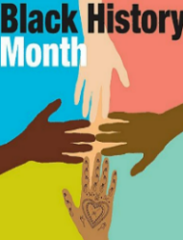  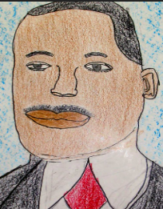  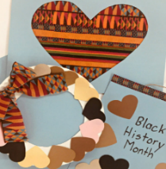  Using collage, paints, crayons or colour pencils create a piece of art that relates to ‘Black History Month’ or a story that you have read.

