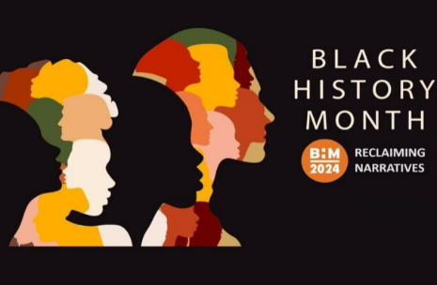
Black History Month Homework -EYFS
This Black History Month 2024 we want to embrace the theme ‘Reclaiming Narratives. It’s time to take control of our stories celebrate our heritage and ensure our voices are heard.
 | Be a Writer | Be a Reader and a good listener | Be an Artist
In the UK, Black History Month falls in October each year and is a great time to learn about and celebrate Black history and heritage. However, Black history can, and should, be recognised and celebrated all year round.  Children should choose a minimum of two tasks.  Stickers will be awarded upon completion of their projects.  Have Fun! | Rosa Parks  Draw a picture related to the Rosa Parks story.  Support your child in writing a sentence about their picture. | What is Black History Month? –  https://www.youtube.com/watch?v=hx-tPbcgNOE  Listen to this video with your child and talk about it. | Draw a picture of Rosa Parks, which you can then colour or paint.  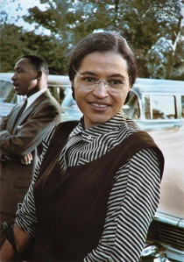  These are some examples your child could use.  
 | Early Years will be reading the story ‘Handas Surprise’ this month.  https://www.youtube.com/watch?v=ocnRQi89nK8  (link to story)  Support your child in drawing a shopping list for fruit and use initial sounds to label. | Rosa Parks was an important part of Black History.  Listen to this story with your child and discuss:  https://www.youtube.com/watch?v=jFlm-GtsUkE  -Who was Rosa Parks?  -What important thing did she do? | Early Years will be reading the story ‘Handas Surprise’ this month.  Recreate the front cover of this story using colouring pencils, crayons, or paints.  

