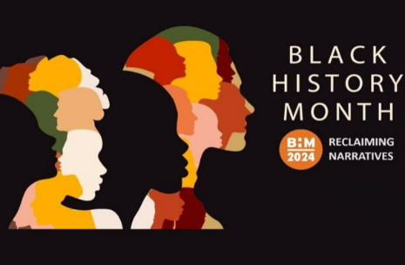
Black History Month Homework -KS2
This Black History Month 2024 we want to embrace the theme ‘Reclaiming Narratives. It’s time to take control of our stories celebrate our heritage and ensure our voices are heard.
 | Be a Writer | Be a Reader and a good listener | Be an Artist
In the UK, Black History Month falls in October each year and is a great time to learn about and celebrate Black history and heritage. However, Black history can, and should, be recognised and celebrated all year round.  Children should choose a minimum of one task per section or more if they wish.  Value stamps will be awarded upon completion of their projects.  Have Fun! | Did you Know? – Research Project  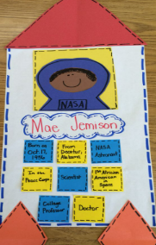  Explore inspirational black authors or illustrators and present information in the form of a report, a quiz, a fact file or a poster.  Possible authors –  Jasmine Richards – Author  Who Is: Serlina Boyd - City Kids Magazine | Black History Month Explained – Newsround (listen)  https://www.bbc.co.uk/newsround/av/41453182 | Design and create a picture that reflects the theme of ‘Reclaiming Narratives’.  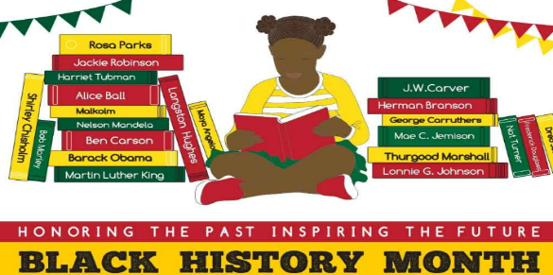
 | Read a book by an inspirational black author and then…  Interview a character  Write down questions that you would like to ask a character if you had a chance to meet them  OR  Create your own character to join a character from the story that you have read. The new character could even be YOU! | Diversity and Parliament: Why is it important to celebrate Black History Month?  https://youtu.be/dSfUfuXxpwI?t=12  (listen)  Read about the life of a current inspirational black person. | 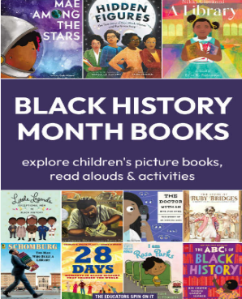  Re-create the front cover of a book that you have read especially for ‘Black History Month’.
 | Listen to ‘Faceless’ by Benjamin Zephaniah  https://youtu.be/B8YgeGaLmSg?t=2  BBC Three - Smile it could be verse, A reading of the poem 'Clever Trevor' by Benjamin Zephaniah  Create your own poem about an inspirational black person that you have researched information about. | You may know the story of Rosa Parkes, but have you heard of the …  story of Bristol Bus Boycotts in England? (listen)  https://youtu.be/uSyzaXXKUaQ  Remembering the first black bus driver in Bristol.  https://youtu.be/Nht6pyQFQ40 | 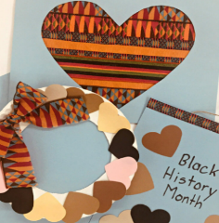  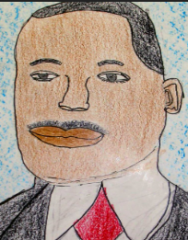  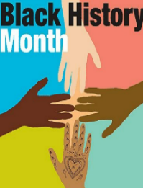  Using collage, paints, crayons or colour pencils create a piece of art that relates to ‘Black History Month’ or a story that you have read.

