Y4 Windrush Generation Film Homework
https://youtu.be/8ULP-2HRgTk
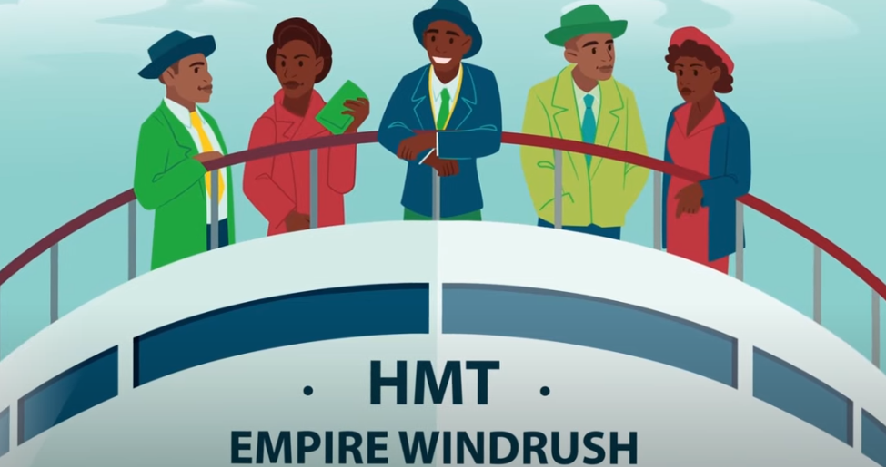
Watch the cartoon film clip and then complete one of the activities below.

The best examples will be added to a display in our school hall.
Creative writing Activity
Imagine you were on board the Empire Windrush. Write a diary entry describing your experience. How would you have felt? What would you have seen / heard whist you were on board the ship?
Diary Entry Success Criteria - past tense, first person (I, my, me), point of view-thoughts and feelings, include some facts, use time conjunctions (first, after that, finally)
OR
Factual Writing - Choose and answer two of the following questions.
What did you learn about the Windrush generation from the film?
What challenges did the Windrush generation face when they arrived in Britain?
How did the Windrush generation contribute to British culture and society?
How might it have felt to be a member of the Windrush generation living in the UK during that time?
OR
Creative Art
Create a piece of art to symbolise the Windrush story. Write a caption to explain it.

