Year 4 Autumn Term 2021 Homework - Visitors from Other Shores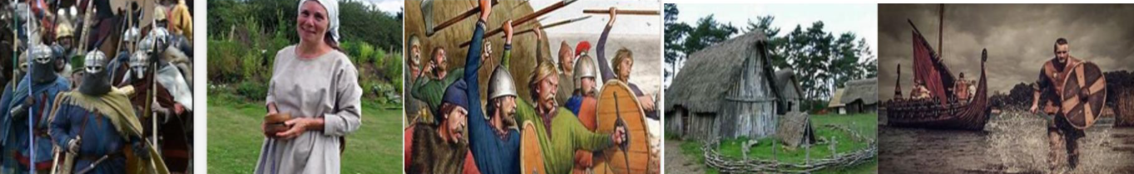
 | Be a Writer | Be a Mathematician | Be an Artist
Please choose a minimum of one task per section or more if you wish.  You will be awarded house points and certificates upon completion of this homework.  Daily Reading  -Reading Book  -Bug Club  All homework to be completed and returned to your teacher by 13th December 2021.  Have Fun! | Kennings were used in Anglo-Saxon poetry as descriptive language. A Kenning is when you take two words and combine them as a metaphor for something else. For example, a wave-floater is a ship. Kennings were often used to describe everyday people, animals, and objects. Read the example of a kenning poem and then create your own.  Bird  a nest-maker  a cushion-filler  a seed-muncher  a fish-guzzler  a fast-flier  a cat-escaper  a tree-liver  an acrobatic-glider  an adventurous-swooper  a tweeting-singer  Put these together,  I’m a bird! | Complete the subtraction calculations on the white sections of the Anglo-Saxon Shield. Round the numbers on the red cross to the nearest 1000.  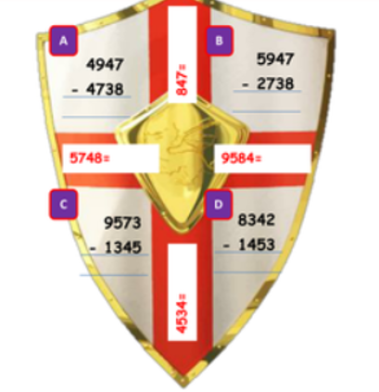 | Jewellery was worn by both Anglo-Saxon men and women. Women fastened their dresses at the shoulder with a pair of brooches. Men fastened cloaks with brooches and had elaborate belt buckles.  Design and make a replica piece of Anglo-Saxon jewellery.  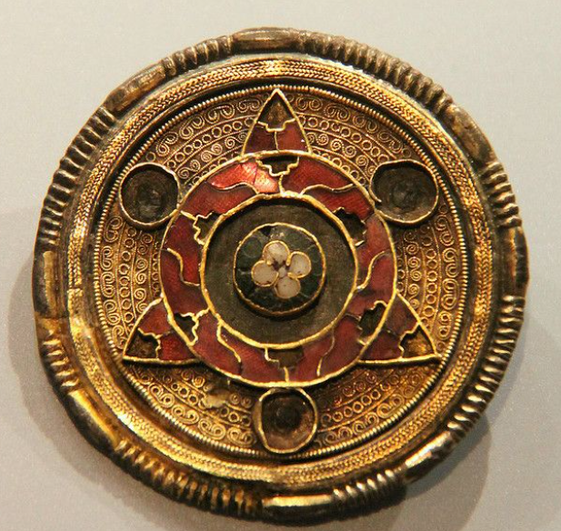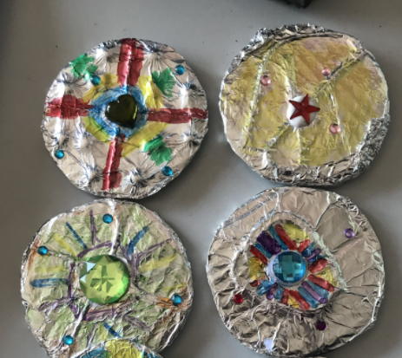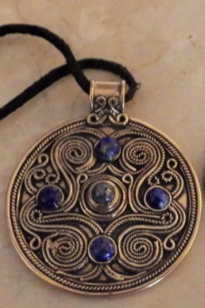  Brooch Necklace
 | The Anglo -Saxons were keen story tellers. They would gather in great feasting halls and tell stories such as the story of ’Beowulf’.  ’Beowulf’ https://youtu.be/g0MJ1IcuPJI  Create your own ‘mini saga’ about a hero in 100 words.  Your story must have a clear beginning, middle and end and include adjectives, verbs, expanded noun phrases and ambitious vocabulary. | Place Value - Practise partitioning numbers up to 9999  Ensure you label the value of each number correctly for example - 28 = 20 + 8 342 = 300 + 40 + 2  7865 = 7000 + 800 + 60 + 5  Counting - Practise counting in multiples of 5,10, 25, 50, 100 and 1000  Example - 25,50,75,100,125… & 50, 100,150,200, 250 … | From earliest times, the Anglo-Saxons were famous for their embroidery  . 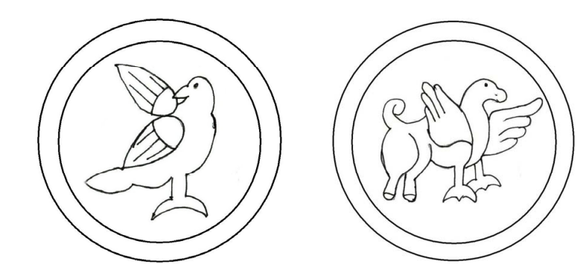 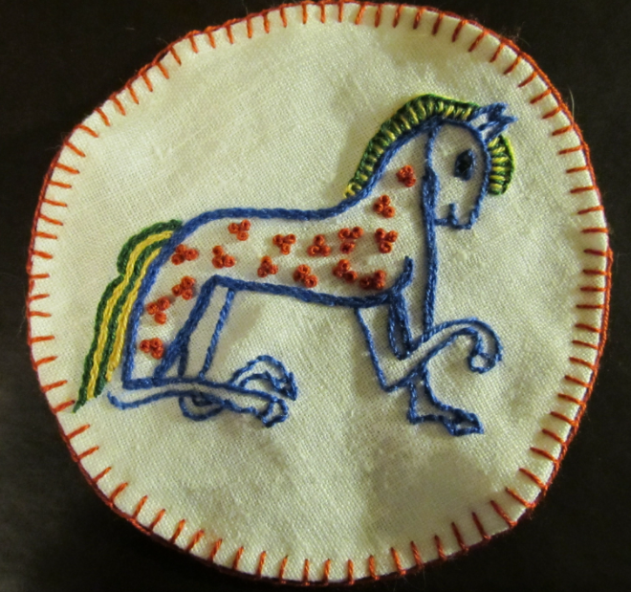  Be creative try some embroidery on a piece of fabric.
 | Suffixes  A suffix is a string of letters that go at the end of a root word, changing or adding to its meaning.  Fact: Place names give a clue to the history of many towns and villages. Suffixes such as ‘-burgh’, ‘-fort’, ‘-ham’, ‘-sted’ and  ‘-ton’ suggest that a settlement has Anglo -Saxon origins.  Task: research the meaning of these suffixes. Can you find any other Anglo -Saxon place name suffixes? What do they mean?  What does the name tell you about the place? | Practise times tables up to 12 x 12  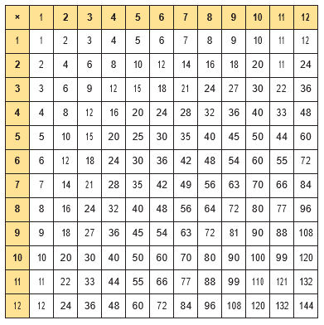 | Research, then draw and labels / information about what an Anglo-Saxon man, woman or child may have worn and what they may have looked like.  

