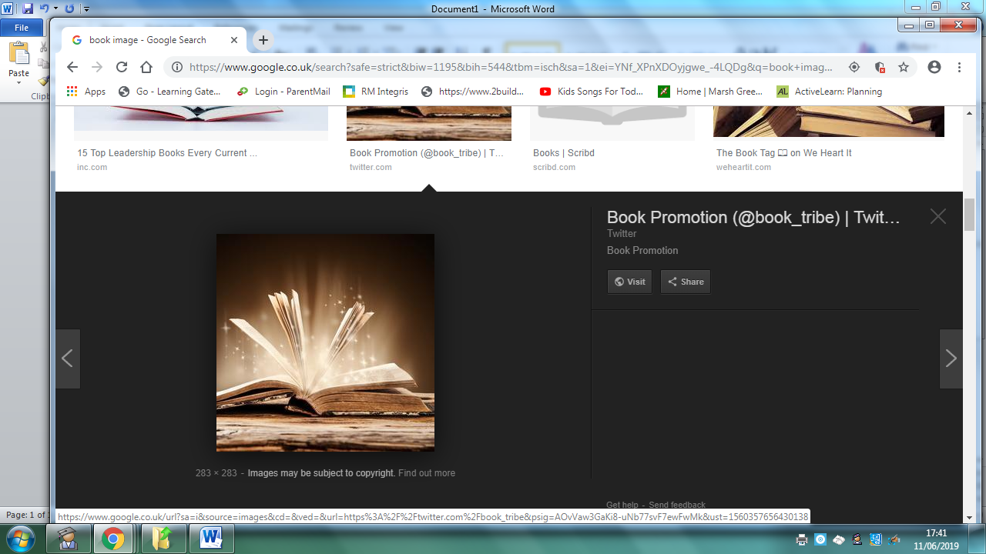
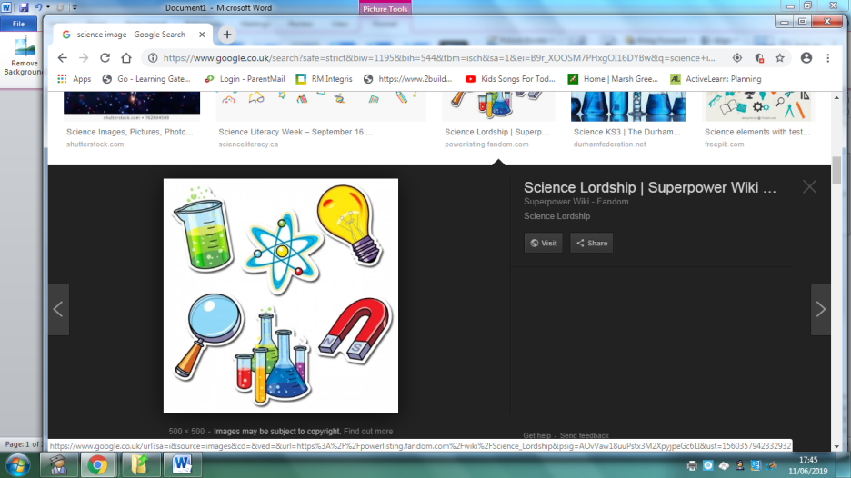
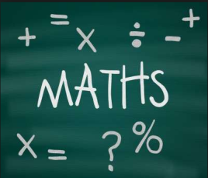
Homework
Year 6 Topic: Volcanoes
 | Be a Writer | Be a Detective | Be an Artist
The children should choose a minimum of one task per section or more if they wish.  Children will be awarded house points and certificates upon completion of their projects.  Year 6 are expected to present homework that reflects their knowledge and skills.  SATs preparation and revision will continue to be sent home weekly.  It is vital ALL children know their division and multiplication facts up to the 12 times table. There are a range of useful links on our maths page on the school website. | Publisher/Word Information Poster  Choose a volcano of your choice and using your ICT skills create an information poster.  Include an effective title, text and images. You will need to insert text boxes and cut and paste if using publisher. Experiment with the font and the overall presentation. Remember the purpose is to provide information. | The Water Cycle (Science Link)  You have the freedom to represent the water cycle in any style you wish, for example – you may want to dance, make an iMovie, write a report, make a model etc etc. Have fun with it. | Hokusai Artwork.  Using the style of Hokusai create your own piece of art. This can be painted, drawn or collaged.  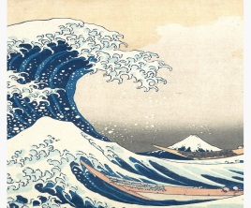
 | Write a biography about Hokusai the Japanese artist.  Include key information such as when they were born, where they lived, the art they created and why they are famous. The biography should be presented neatly and provide enough information for the reader.  Ask your teacher if you need paper. | Pompeii.  Find out about Pompeii – where is it, what happened to it, how did people live their lives in Pompeii? You can choose how you wish to present this information.  www.dkfindout.com | Make your own Volcano  Create your own volcano.  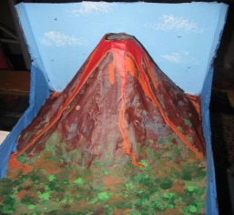
 | Write a first-person diary entry as a Volcanologist who has just managed to escape an erupting volcano!  You need to inlude…  -Date  -‘Dear Diary…’ to start  -First line summary ‘Today has been scary…’  -Chatty style  -First person ‘I’  -Past tense  -Questions  -Hopes for the future | Volcanoes of the World  Using a map of the World (please ask your class teacher if you need a map) identify the active volcanoes around the World. You will need an atlas or the internet. You need to spell the names correctly and include the names of the continents the volcanoes can be found on. | Roman Mosaic  Create a Roman Mosaic fit for a Roman villa. Look at how mosaics are created. You can use coloured squares to create your own design.  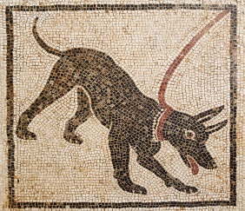
Homework is due on March 25th 2022

