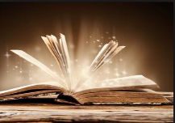
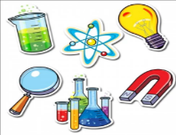
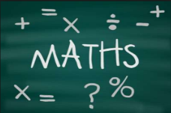
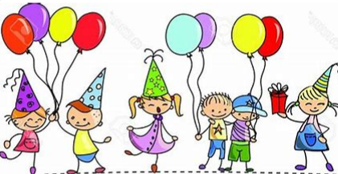
Homework
Year 3/4 Topic: Celebrations in our Community
 | Be a Writer | Be a Detective | Be an Artist
Children should choose a minimum of one task per section or more if they wish.  Children will be awarded house points and certificates upon completion of their projects  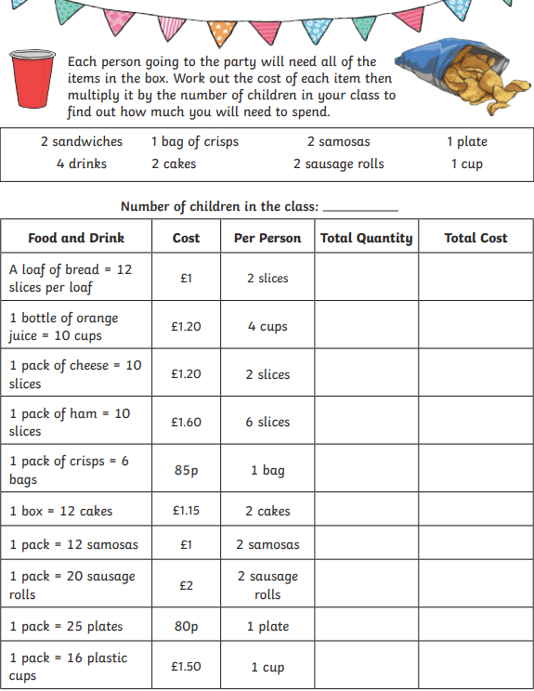  Celebration Party Planning  Homework is due on Monday 27th June 2022 | Write about a personal family celebration.  This could be in the form of a recount or a poem.  E.g. Birthday, Christening, Wedding, Anniversary | What is a jubilee?  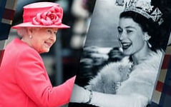  Create a leaflet to explain why and how Queen Elizabeth 2nd’s Platinum Jubilee is going to be celebrated? | 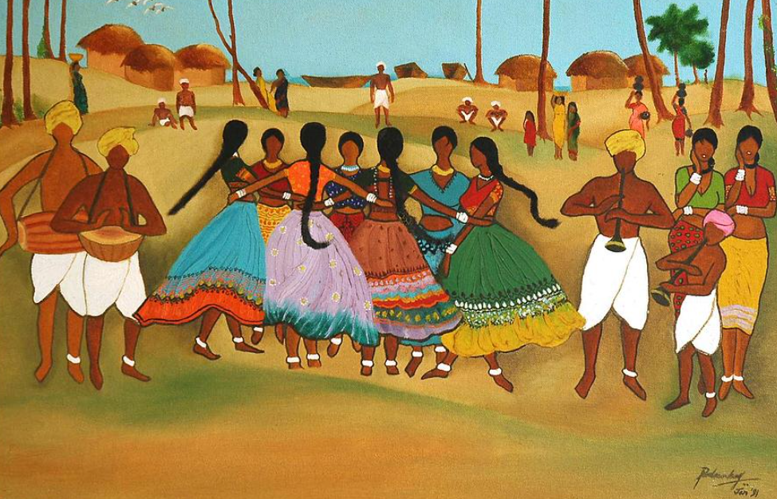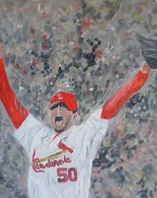  Celebration Painting by Padmakar Kappagantula. Celebration by John Terry  Choose one of the paintings above and answer the five questions in complete sentences.  What can you see in the painting?  What are the most common colours used?  Why do you think the artist painted this picture?  How does the painting make you feel?  What do you like about the painting? Why?
 | Write a non-chronological report about religious celebration that you have participated in or one that you are interested in.  E.g. Easter, Eid, Chinese New Year, Christmas, Diwali, Hanukkah, Kwanzaa | All celebrations need a party with food and drinks. Work out the cost of a celebration party for your class.  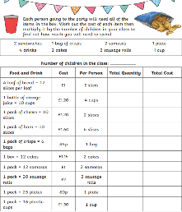 | Create and design a piece of celebration art of your own – using any media.  E.g. paint, crayon, chalk or fabric.  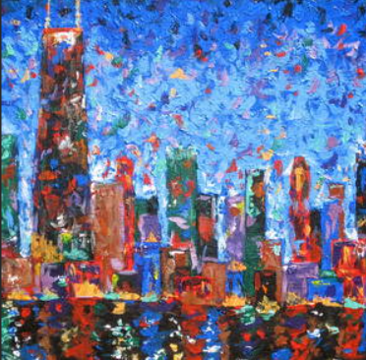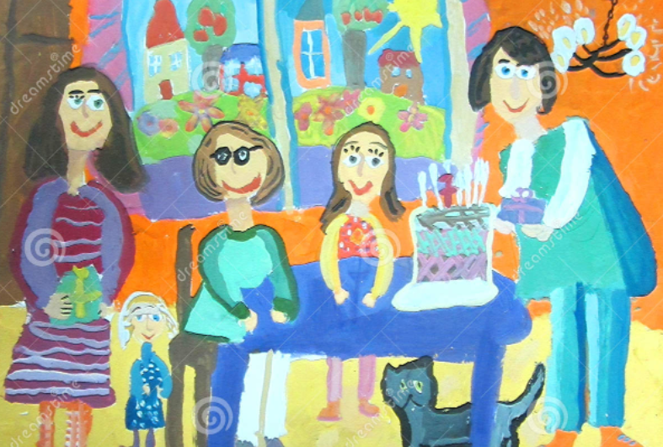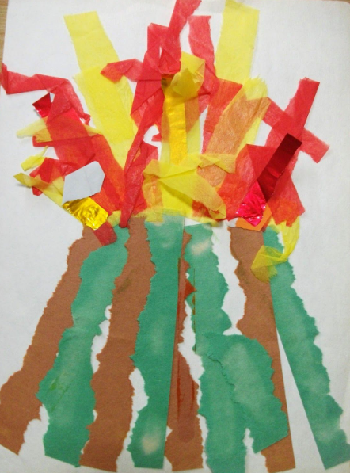  Celebration City by J Loren Reedy
 | Plan, design and write an invitation for a school celebration to be held in the summer term.  E.g. Music Festival, Awards Celebration or Y6 Leavers Celebration | Research a celebration that occurs in one of the commonwealth countries and create a poster about it.  E.g. The Chocolate festival held in Belize. | 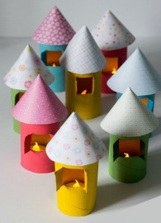  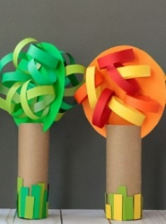  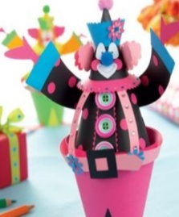  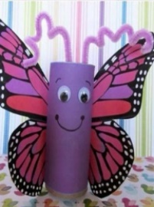  Design a 3D free standing structure (centre piece) for a celebration meal  Use kitchen rolls or rolled card (no toilet rolls) please.

