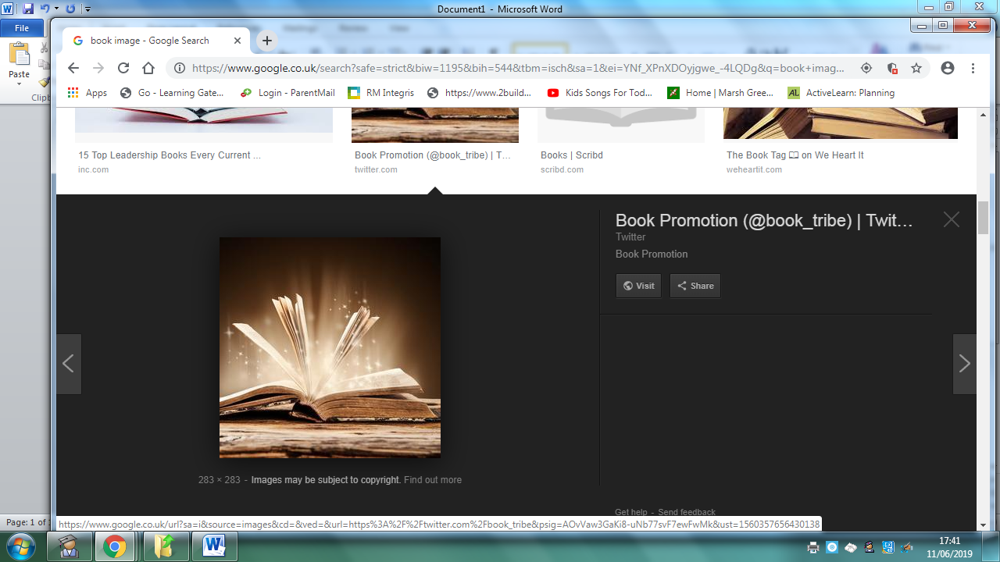
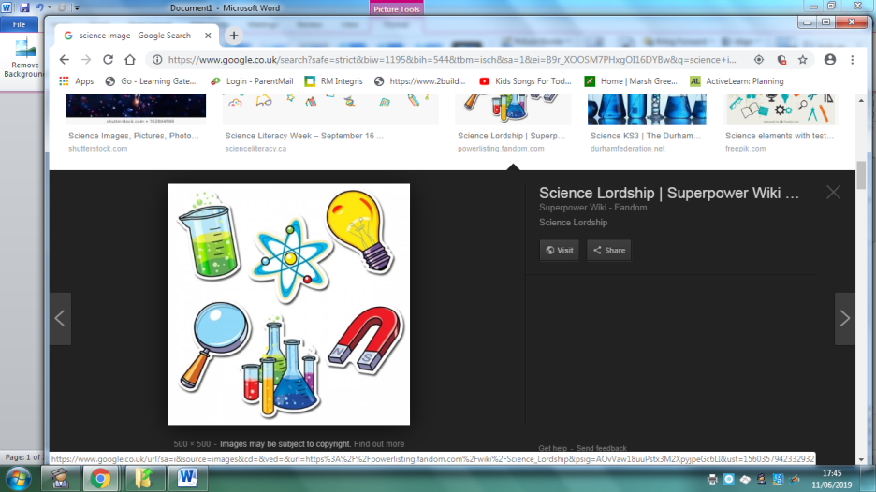
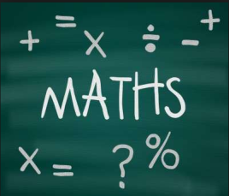
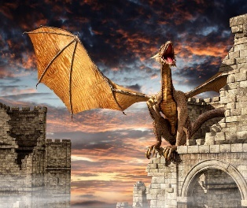
Homework Year 3 Spring Term Topic: Dragon Slayer
 | Be a Writer | Be a Detective | Be an Artist
The children should choose a minimum of one task per section or more if they wish.  Children will be awarded house points and certificates upon completion of their projects  Homework is due on  Friday 25th March 2022 | Write a shape poem about dragons.  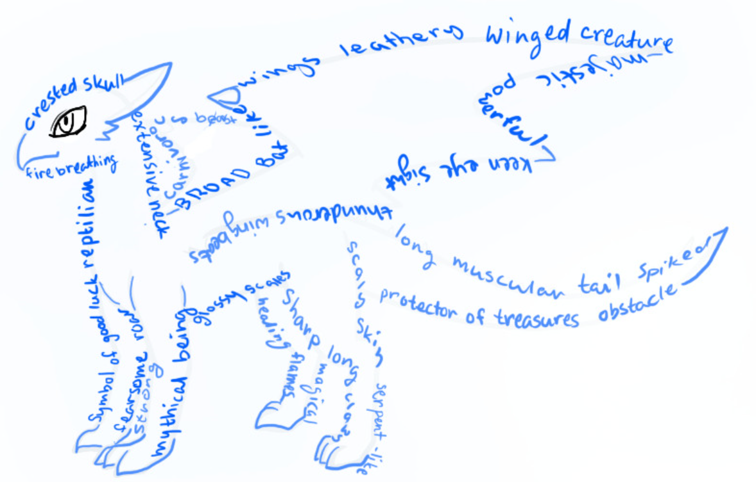A Shape Poem is a poem that describes an object. The poem is shaped the same as the object that it is describing. | Research  Find out about two different types of dragon.  Create a fact sheet about their similarities and differences. (Draw / label the dragons and write information about each one) | Create a diorama (a miniature scene) with a dragon and / or a cardboard castle  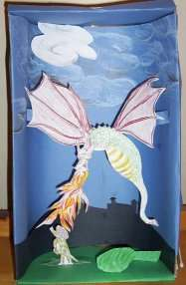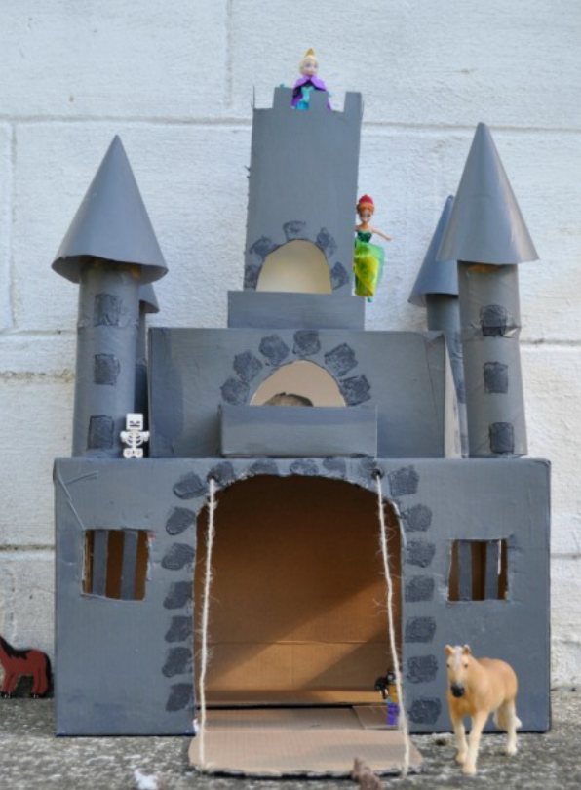
 | Write a non-chronological report about dragons  Include some of the following words/information…  -Title  -Introduction - to introduce topic  -Appearance / size  -Habitat  -What they need to survive  Include pictures and captions  Use formal language | Research questions and answers  – Make your own dragons and ladders board game for a variety of mixed maths problems  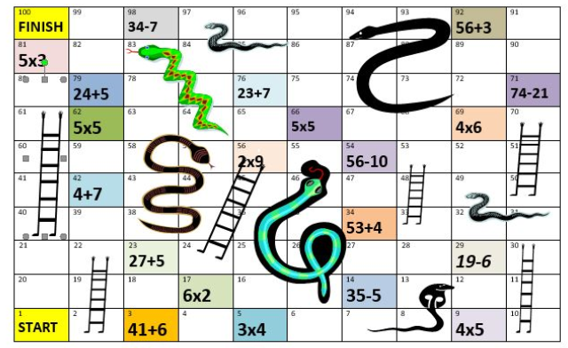 (÷ × + - £ and p) | Create your own dragon image using drawings of parts of different real-life animals (label which parts come from which animal)  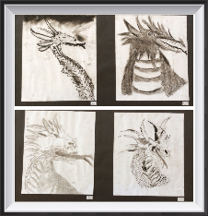
 | Create a ‘Wanted Poster’ for a dragon. 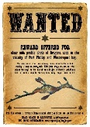  Your poster must include the following  - A drawing of the dragon  - Characteristics…  - Wanted for…  - Last seen…  - Reward… | Research  What do people from different cultures or countries believe about dragons?  -You could find out about the importance of the Chinese Dragon within the Chinese culture. | Paint a picture inspired by George and the Dragon (England’s Patron Saint).  

