Who would you recommend the book to? Why?
I think any person that likes to find out about exploring and having adventures would like this book.If you can’t read it yourself, ask an adult to read it to you and share the adventures together.
Book Illustration

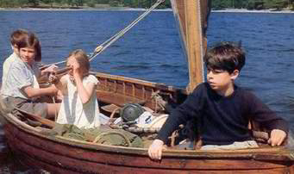
Can you write three facts you have learnt or three things you have learnt about one of the characters?

Susan is the second oldest child.

She organises the others and does the cooking.
Susan gets sea sick (not good when you do lots of sailing)
What is the book about?
The book is about a family with 4 children who go on holiday to the Lake District. Their holiday home is on the edge of a lake which has an island. The children make the island their secret hide away and camp on it. They have lots of exciting adventures on their own, sailing the 14 foot sailing boat around the lake. Mum has made them tents and they cook on a camp fire. What they didn’t know was that another family of children, live nearby and sometimes use the island. They play tricks on each other, setting challenges and having lots of fun while at the same time having to think about solving problems…..
Fiction or Non-fiction: Fiction

Author: Arthur Ransome

Book Title: Swallows and Amazons

Rating:

Book Review

