DOGGER
My Favourite toy
In Dogger, Dave’s favourite toy was an old, soft brown toy that looked like a dog and was called Dogger. Dave took Dogger everywhere and played with him all of the time. He even took him to bed and slept with him.
When I was younger, my favourite toy was a colourful, knitted doll, that looked like a scarecrow. He was called George! George had bright yellow hair, patched trousers, braces to keep his trousers up and a green jacket. He wore a colourful striped jumper.
George was my best friend and came everywhere with me, my friends all loved George. He was knitted by a friend of my mum’s called Peggy. The only place I didn’t take George was in the bath!! Being a scarecrow, George didn’t like to be too clean…
I became very upset one day because I took George to play group where my friends all played with him. When it came to home time I couldn’t find him. We looked everywhere but he had disappeared. My friends mums said they didn’t have him but he couldn’t run away could he??? I was heart- broken. Peggy kindly knitted me another, Sam, but he wasn’t the same; he wasn’t my George!!!!
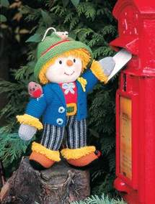This is Sam.
Think about when you were younger. What was your favourite toy? Draw a picture of it and write some sentences about it. Remember to include extended noun phrases and extra information using commas. Can you use commas in a list for 3 things with and before the last one? Draw a picture.

