3 D Shapes
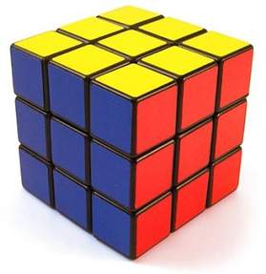
Cube: 6 square faces; 8 vertices(corners); 12 edges
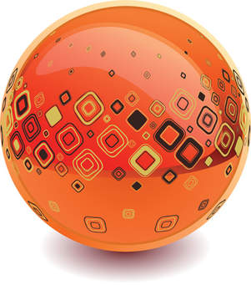
Sphere: 1 curved face; no vertices; no edges
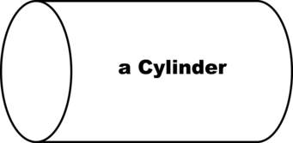
Cylinder: 1 curved face and 2 flat circular faces
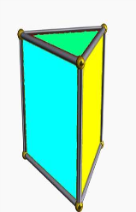
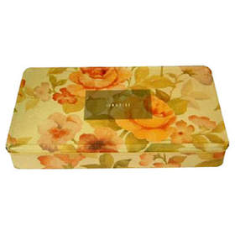
Cuboid: 6 faces; 3 sets of equal and opposite faces; 12 edges; 8 vertices, corners
Triangular Prism: 5 faces, 3 rectangles all the same, 2 equal triangles. 6 vertices, 9 edges.

Walk around your home and local environment, look for the shapes in the table below. When you find one, write onto the table what it is. I have done one for you.
3 D shapes
Cube | Sphere | Cylinder | Triangular prism | Cuboid
Dice

