Maths- measurement 1
Grams (g) and Kilograms (kg)
We use g and kg to measure the weight of things.
Remember 1000g=1kg
500g = ½ kg
250g = ¼ kg
I HAVE LOOKED AROUND MY HOUSE AND HERE ARE 3 THINGS I HAVE FOUND ;
Baked Beans tin 415 g 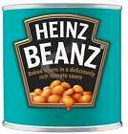
Vitamin capsules 96 g 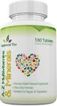
Toffee 200 g 
Now you go and look around your house, find 3 things write their name and weight and draw them.

1__________________________________

2__________________________________

3__________________________________
Write all of the weights including mine;
415g 96g 200g _____________ ________________ _______________
Order them starting from the lightest( smallest weight) to the heaviest ( biggest weight)
_____________ ___________ ______________ ___________ ___________ _________

