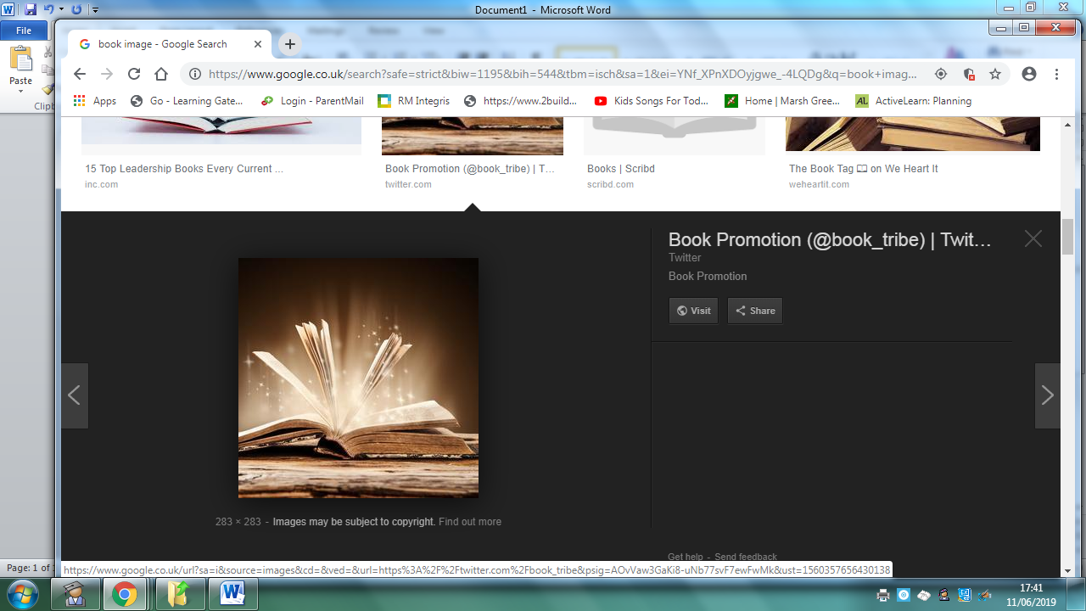
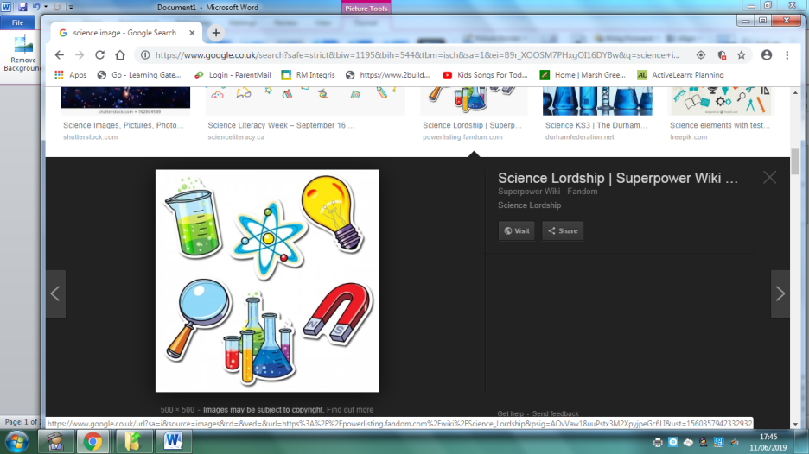
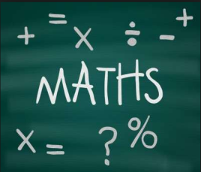
Homework
Year 5 Topic: World War II
 | Be a Writer | Be a Detective | Be an Artist
The children should choose a minimum of one task per section or more if they wish.  Children will be awarded house points and certificates upon completion of their projects  Abacus Homework on line. | Powerpoint  Create a powerpoint about World War II. How did it start? What countries were involved? Who were the war-time leaders? How long did the war last? Did any of your grandparents or great grandparents fight during the war- perhaps they have medals or stories they can share with you. | Planets (Science Link)  Create a poster about the Solar System – label the planets and provide key facts about the planets. | Listen to the Planets by Gustav Holst. Write about how this music makes you feel, do you think it represents the planets? Why do different sections of the music have different planet names? Does the music accurately represent the planets in your opinion – justify your opinion.
 | Write a biography about a war-time leader.  Include key facts about their life and why they are famous.  You need: Formal language. Past tense. Joined handwriting. Relevant facts. | Spy Code  Research code breakers and create your own coded message.  https://bletchleypark.org.uk  What skills do you think you need to be a spy? | Anderson Shelter model.  Create your own Anderson shelter. Research Anderson Shelters. You will need: a shoebox, paper and glue.  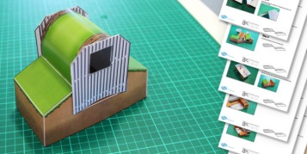
 | Write a first-person diary entry as a child who has been evacuated during the war.  You need to inlude…  -Date  -‘Dear Diary…’ to start  -First line summary ‘Today has been scary…’  -Chatty style  -First person ‘I’  -Past tense  -Questions  -Hopes for the future | Timeline of World War II  Create a timeline of key dates and events for World War II. You will need a ruler and paper to create a timeline. https://www.natgeokids.com | War Time Posters  Create your own war-time poster with a message.  
Homework is due on or before November 22nd 2019

