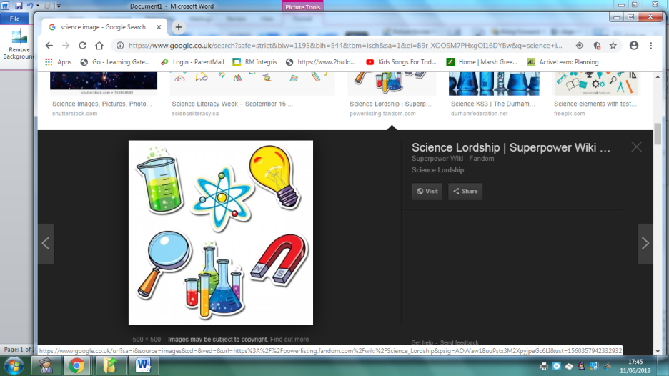
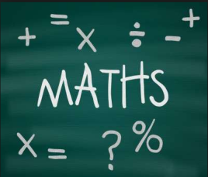
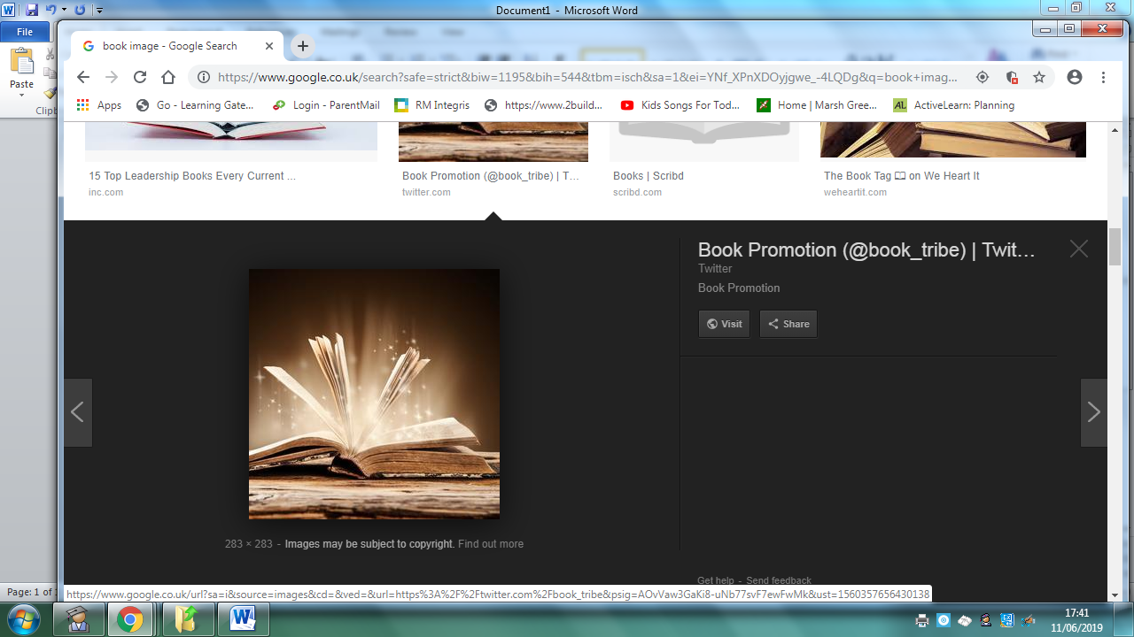
Homework
Year 5 Topic: The Shang Dynasty
 | Be a Writer | Be a Detective | Be an Artist
The children should choose a minimum of one task per section or more if they wish.  Children will be awarded house points and certificates upon completion of their projects  Abacus Homework on line.  Homework is due on or before March 20th 2020. | PowerPoint  Create a PowerPoint about The Shang Dynasty  How did it start? Important rulers? How long did it last for? Main event that happened during the Shang Dynasty?  Or  Create a PowerPoint highlighting the differences between China during the Shang dynasty and Modern day China. | Create your own Shang dynasty quiz.  Create a multiple choice quiz game in the style of ‘Who wants to be a millionaire’.  E.g. Where did The Shang Dynasty start? A. China, B. England, C. Germany D. Australia. | Listen to traditional Chinese music.  Write about how it makes you feel and what instruments you can hear throughout the song.  Or  Can you learn some traditional Chinese phrases? E.g. Good Morning/Night, Hello, How are you etc.  Learn them and teach them to the rest of the class/year group throughout our new topic!
 | Write a biography about lady Fu Hao.  Who was she? Why was she important? What new ideas did she implement? Why was she unusual? | The Shang were the first Chinese people to invent writing. The Shang people, who lived over 3000 years ago, etched characters - pictures - onto bones. Shang writing is known as 'oracle bone script'. The oracle bone script developed into the modern characters which Chinese people still use today.  Can you write words or phrases in Shang ‘Oracle bone script’ and modern-day Chinese lettering? | Chinese dragon model  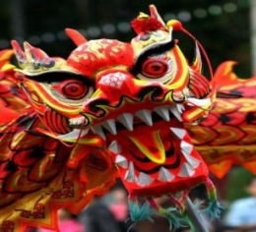  Create your own Chinese Dragon model and find out why it is important part of Chinese history and culture.
 | To write a series of travel blogs exploring China. E.g. Great Wall of China.  This can be written as a diary entry, letter home or a review You need to inlude…  -Date  -‘Dear Diary…’ to start  -First line summary ‘Today has been scary…’  -Chatty style  -First person  -Past tense  -Questions | Create a timeline of the Shang Dynasty  You will need a ruler and paper to create a timeline.  Try to include all of the most important and significant dates/events on your timeline.  Can you include pictures/images too? | Create a Chinese pattern    How creative can you be? Think about using different materials and colours.

