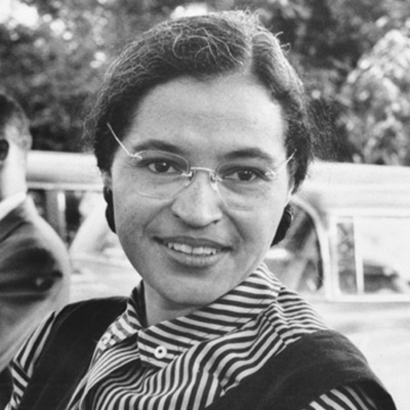
Rosa Parks
Rosa was a black woman born in Tuskegee Alabama, on February the 4th 1913.
Rosa’s mother was a teacher, and her family valued education immensely leading Rosa to earn her high-school diploma. At 19 she got married to Raymond Parks who was a member of National Association for the advancement of Colored People, later becoming secretary of the organisaation.
Roots of Activism
Rosa was a member of Montgomery’s large African American community, co-existing with white people in a city governed by Jim Crow. Segregation laws however, was fraught whith daily frustrations; Blacks could attend only certain inferior schools, could drink only from spesified water fountains and could borrow books only from the ‘black’ libraries, among many other restrictions.
Rosa Park’s Arrest & Change
On the 1st of December 1955, after a long day of work, she was travelling home using the bus. Although the Black resident of Montgomery, often avoided buses because of the Negroes-in- back policy, a segregation law where the front seats of a Montgomery bus was reserved for white citizens, and the seats behind them were for black people, 70% or more riders on a typical day were black. Only bus drivers had the authority to tell a black person to give ther a seat for a white rider .
At one point of Rosa’s journey, a white man had no no seat because there area that they sit was full .So the bus driver asked the black riders in the 4 seats of the first row of the coulord section to stand , the 3 black riders instently stood up, however Rosa refused, leading the arrest of Parks.
This incident brought change, and Rosa later became known as ‘’ the mother of civil rights movement’’. People always say that I did not give my seat because I was tired, but that isn’t true. I was not tired physically, but rather I was tired of giving in always.

