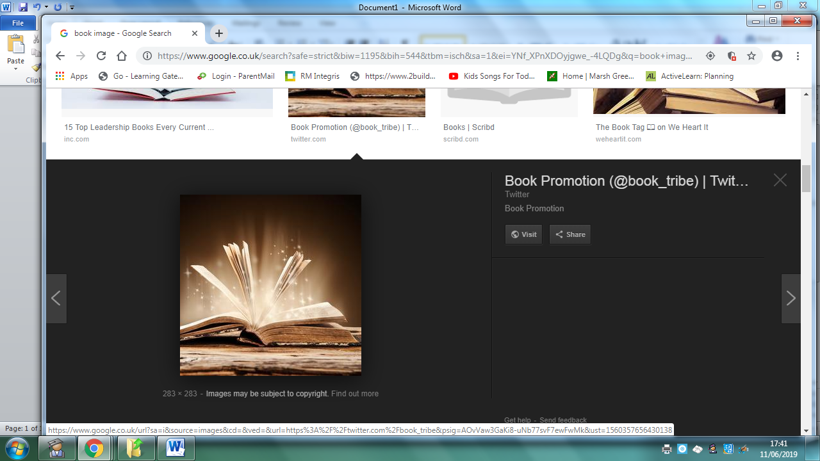
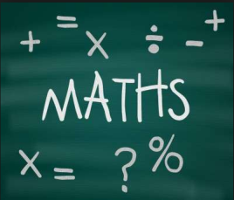
Year 3 Topic: Dragon Slayer
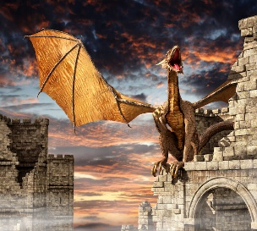 | Be a Writer | Be a Detective | Be an Artist
The children should choose a minimum of one task per section or more if they wish.  Children will be awarded house points and certificates upon completion of their projects | Write a shape poem about dragons.  To create a shape poem, follow these easy steps: | Research  Find out about two different types of dragon.  Create a fact sheet about their similarities and differences. | Create a diorama with a dragon and / or a cardboard castle  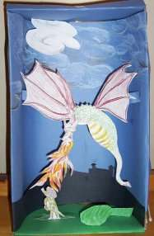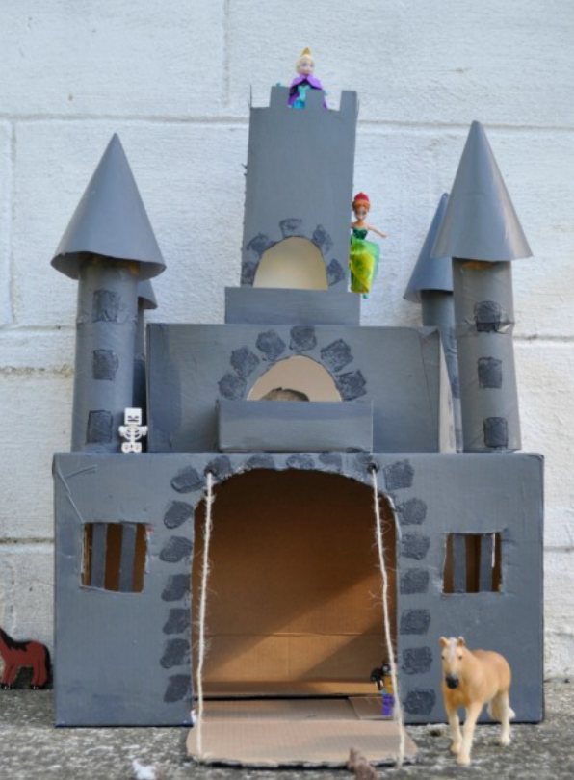
 | Write a non-chronological report about dragons  Include some of the following words/information…  Where do they live?  What do they need to survive? | Research  How and why are dragons associated with castles? | Create your own dragon image using drawings of parts of different real-life animals (label which parts come from which animal)  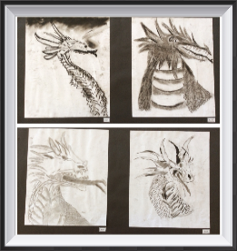
 | Create a ‘Wanted Poster’ for a dragon  You need to inlude… | Research  What do people from different cultures or countries believe about dragons?  -You could find out about the importance of the Chinese Dragon within the Chinese culture. | Paint a picture inspired by George and the Dragon.  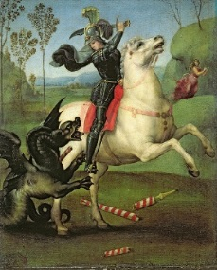
Homework is due on March 20th 2020.

