Summer Topic - Discover Egypt
Use your exercise book to complete the following tasks:

Pre-learning Task 1 – What do you already know about Ancient Egypt?

– What do you want to find out about Ancient Egypt?
(Write at least 4 questions)
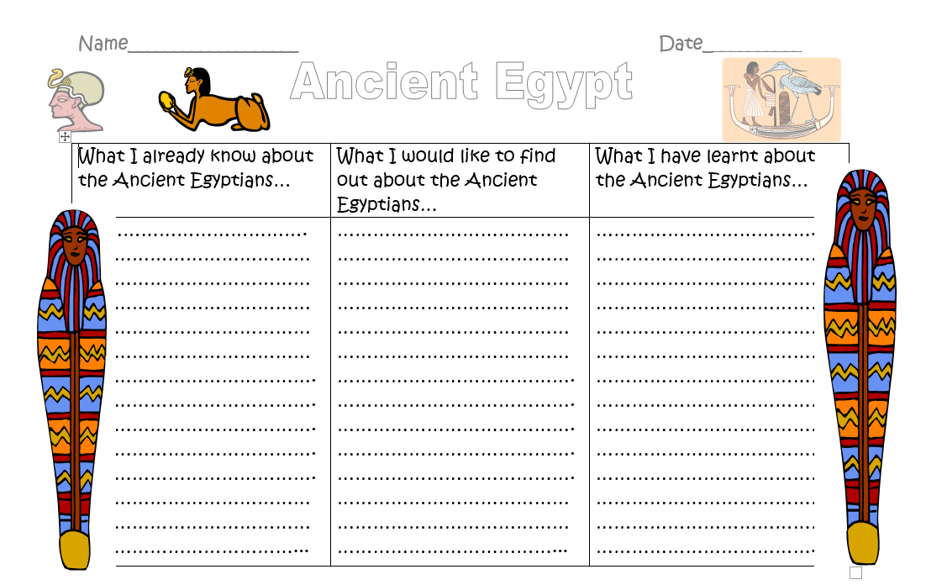

Ask geographical questions: where is this location? (RESEARCH) What is your opinion of it?

Task 2 – Where in the world is Egypt? – Name the capital city of Egypt?
– Write a list of Egypt’s physical characteristics.
(The physical characteristics of a place make up its natural environment e.g. mountains)

– Write a list of Egypt’s human characteristics.
(The definition of Human Characteristics is what has been put in a place, not by nature, but by humans e.g. shops)

Task 3 – Develop an understanding of what modern Egypt is like and how it contrasts with Ancient Egypt.
Choose from one of the following tasks.
a) Create a poster using the information found.
b) Write an acrostic poem using the information found.
c) Write two postcards home, one from modern and one from Ancient Egypt including characteristics.

Useful websites
Junior Jetsetters Fun Egypt Facts for Kids https://youtu.be/gpRmHE-qqR8
Primary Homework Helper – Egypt http://primaryhomeworkhelp.co.uk/egypt/today.html
Horrible Histories - Awful Egyptians https://youtu.be/T7WhIybg_Qo
Ancient Egypt Facts for Kids and adults (around the world with Jazzy K) https://youtu.be/A9KTR2tU9dc

Ancient Map
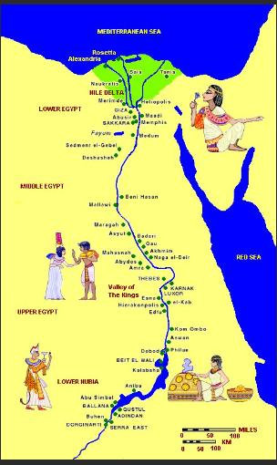

Modern Map



