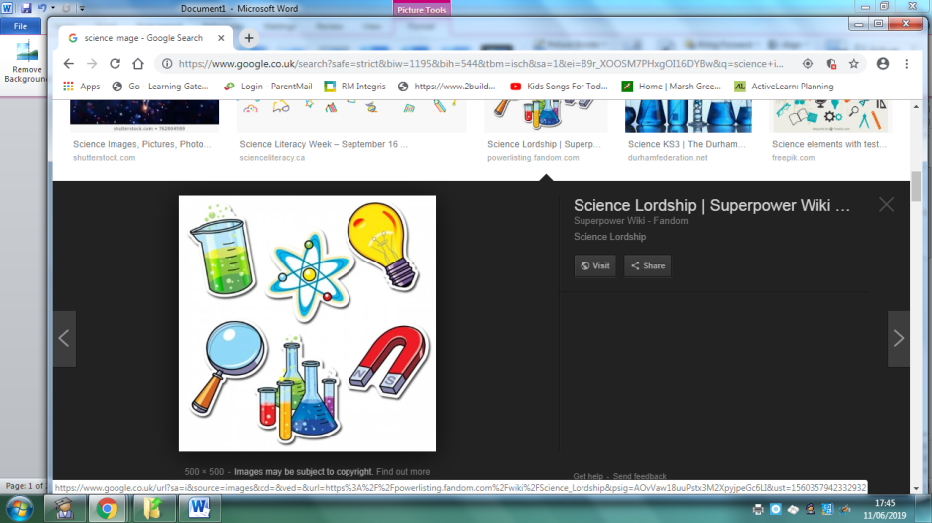
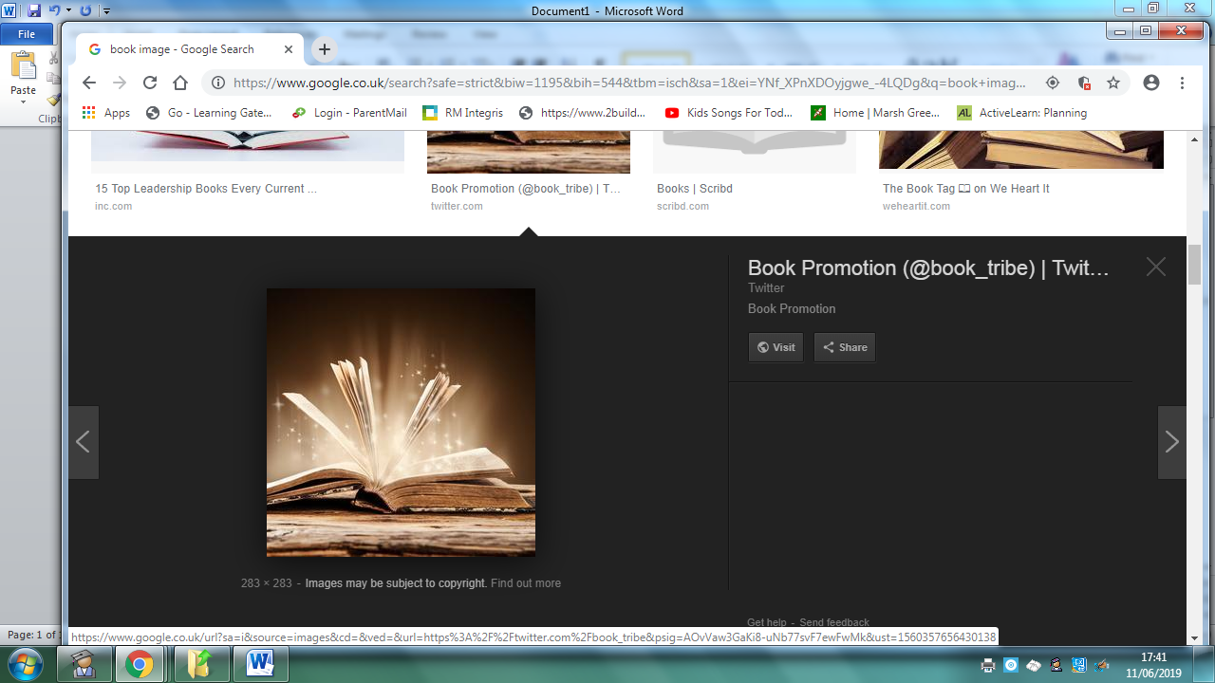
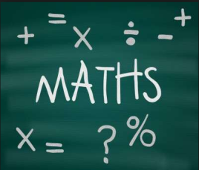
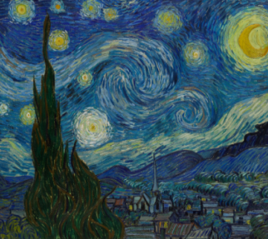
Homework
 | Be a Writer | Be a Detective | Be an Artist
The children should choose a minimum of one task per section or more if they wish.  Children will be awarded certificates. | Can you write your name and draw yourself as a Superhero.  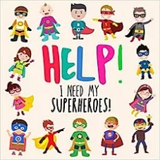  Challenge: Can you begin to label your picture? E.g. mask, cape, goggles etc. | 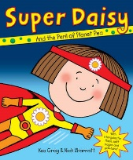  Make jelly and add in fruit to give it a flavour. Does your jelly taste like peas like the one in the Super Daisy book? What can you taste?  Talk to your family about it.  Challenge: How many different types of fruit can you think of? | Can you create a poster? Write as many numbers as you can up to 20 and decorate the poster with superheroes.  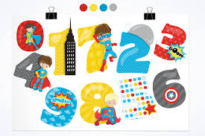  Challenge: Can you write numbers above 20?
 | Can you draw a picture of yourself as a superhero saving somebody or something and write a caption beneath?  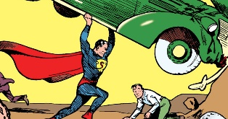  E.g. I saved a cat. | Talk to different members of your family and friends. Find out what superhero powers they would like to have and why!  Challenge: Can you draw a member of your family as a superhero and write their name underneath? | 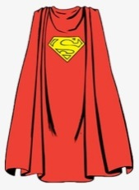  Can you design your own superhero cape?  You can draw or create one! Use your imagination!
 | Can you write your name and draw a picture of food you think a superhero may eat? Think about healthy and unhealthy food. Talk to your family about it!  Challenge: Can you begin to label your plate of food. | Superhero Physical Challenge!  How many star jumps and hops on one foot can you do in a minute?  Do them separately and no cheating!!  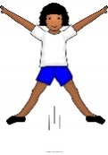  Challenge: Can you do them for two minutes? Can you think of any other exercises to try? | 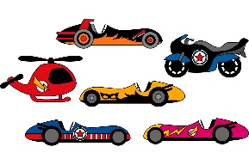  Can you make an amazing superhero vehicle using different materials? Talk to your family about what you are making  E.g. these are lights, these are the wheels etc.
EYFS Topic: Superheroes
Homework is due on: 20th March 2020

