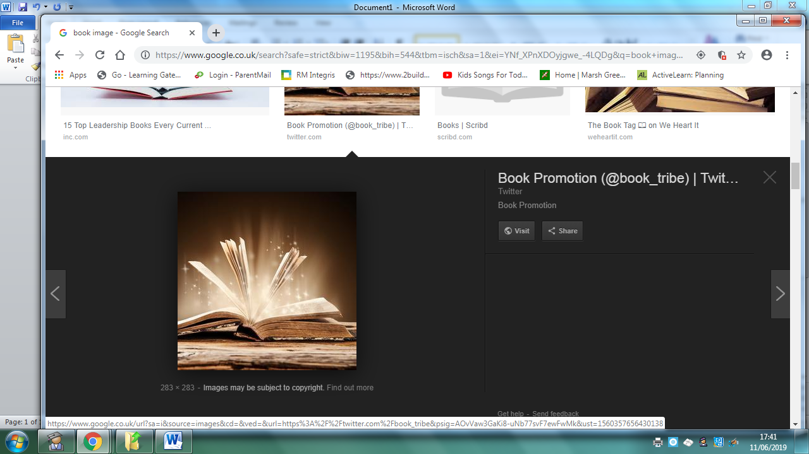
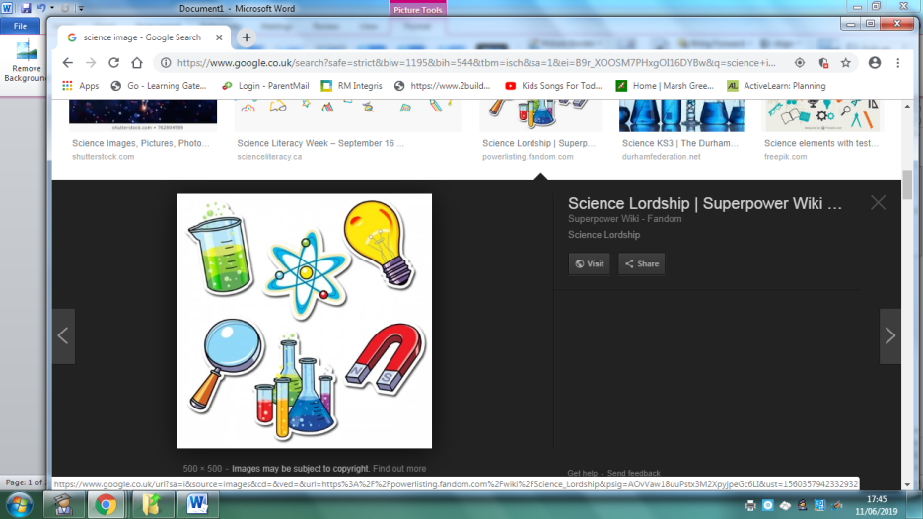
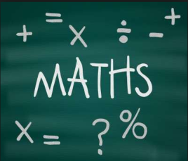
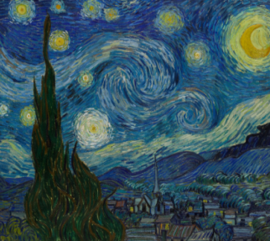
Homework
EYFS Topic: Our World
 | Be a Writer | Be a Detective | Be an Artist
The children should choose a minimum of one task per section or more if they wish.  Children will be awarded certificates | Learn to write your name and draw a picture of your family.  Challenge: Can you begin to label members of your family and write your numbers to 10 or 20. | 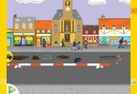  Make a list of things you can see where you live, with help from your family, (shops, cars, doctors, dentists).  Play eye spy. Count how many things you have seen.  Challenge: What is the biggest number you can count to? | Draw a picture of your favourite person or pet, using paint, crayons or collage. Challenge: Can you draw a picture using squares, rectangles, circles, triangles.  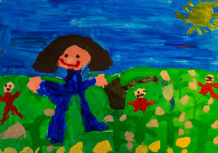
 | Learn to write your name and draw a picture of your favourite food.  Challenge: Can you begin to label your favourite food with help from your family. Count how many different types of food you like. What is the biggest number you can count to? | 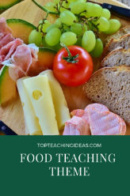  With help from your family sort your favourite foods into healthy and unhealthy categories. Can you make a chart? | 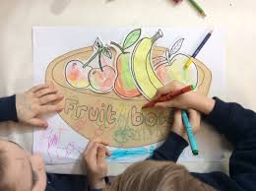  Can you design a fruit bowl with help from your family?
 | Learn to write your name and draw a picture of an owl.  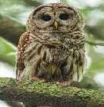  Challenge: Can you begin to label your owl e.g. eyes, beaks, feathers. | Find out facts about other nocturnal animals such as foxes and badgers. | 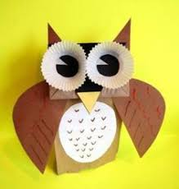  Can you make an owl using different materials? Discuss – How many eyes can you see? How many wings? How many feathers

Homework is due on: 22/11/19

