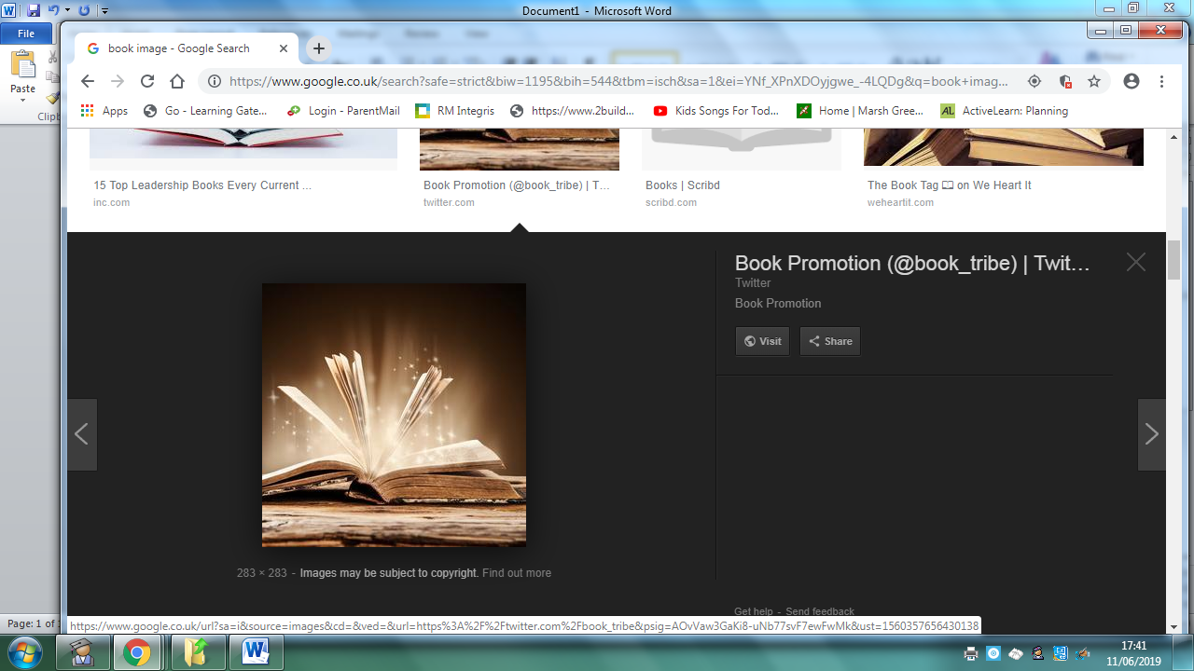
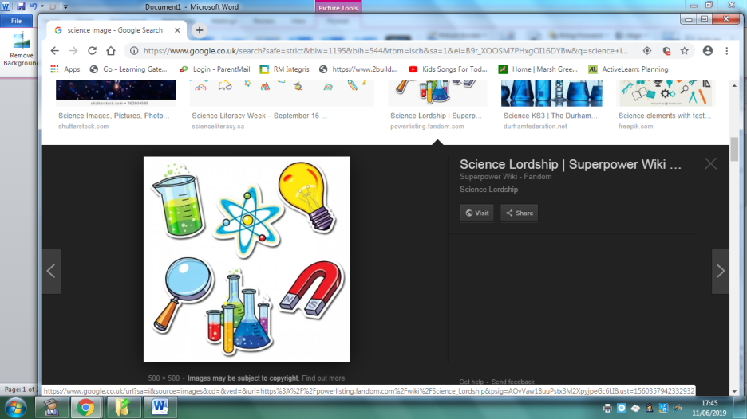
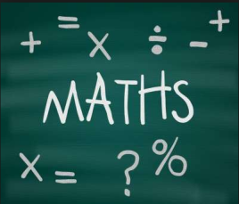
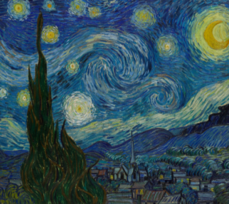
Homework
Year 4 Topic: The Iron Man
 | Be a Writer | Be a Detective | Be an Artist
The children should choose a minimum of one task per section or more if they wish.  Children will be awarded house points and certificates upon completion of their projects | ‘The Starry Night’ by Vincent Van Gogh. Explore Van Gogh’s life and write a short biography that includes …  -Where he grew up  -Early Life  -Letters to his brother  -Life in France  -Legacy  -Other interesting Facts | Identify situations when electricity can be dangerous in different rooms in your home.  Create a safety poster to educate the children in your class (include labelled drawings and factual information). | ‘The Starry Night’ by Vincent Van Gogh.  Re-create a section of Van Gogh’s ‘The Starry Night’ as a 3D model.  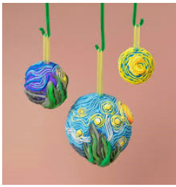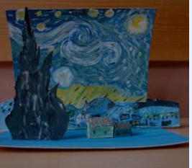
 | Write a letter that would persuade your teacher to buy a robot assistant for the classroom.  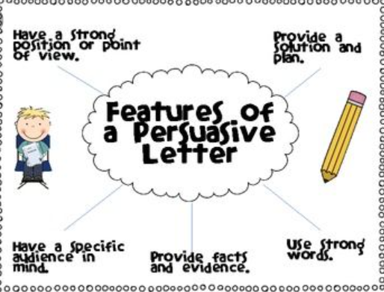 | Conductors and Insulators?  What are some examples of conductors? What are some examples of insulators?  - How are conductors and insulators used in your home to keep you from injury caused by electric shock?  - Create a chart that could be used to record your observations. | The Starry Night’ by Vincent Van Gogh.  Re-create a section of Van Gogh’s ‘The Starry Night’ using a different medium such as chalks, fabrics or coloured paper. Include shades of dark and light.  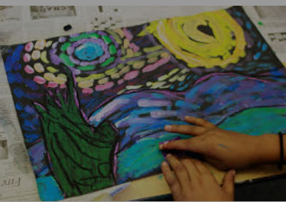
 | Are robots a good thing?  Write a discussion that includes both sides of the question.  You need to inlude the language of debate… | Domestic Robots  What are domestic Robots?  Is Alexa a robot?  What robots are used in our homes today?  Draw and label 4 different examples and write an informative caption for each one. | The Starry Night’ by Vincent Van Gogh.  Re-create Van Gogh’s ‘The Starry Night’ inspired by a view from a room in your home in e.g. Dagenham.  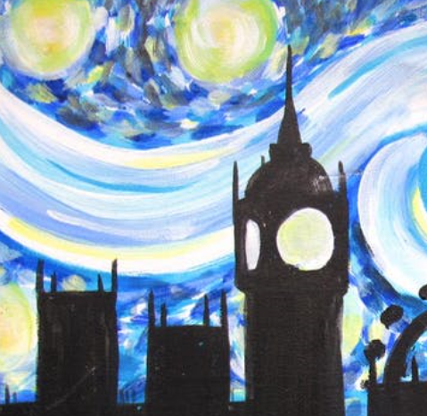
  Many people believe… | On the other hand…
  We have various reasons for… | However…
  Our first reason… | Alternatively…
  Furthermore… | Whilst some people think…. Many also believe…
Homework is due on ______________

