


Homework
Year 4 Topic: Incredible Sports
 | Be a Writer | Be a Detective | Be an Artist
The children should choose a minimum of one task per section or more if they wish.  Children will be awarded house points and certificates upon completion of their projects | Explore a local sportsman or woman’s life and write a short biography that includes …  -Where they went to school  -Early Life  -Their inspiration  -Their path to success  -Other interesting facts | Japan’s time zone is different to ours in the UK. Can you investigate the time difference and distance between the two countries and present it, in the most creative way possible.       |   As Japan are hosting the 2020 Olympics, we will look at the great Japanese artist, Hokusai. Can you create a landscape in his printing style.
 |   Write a newspaper article reporting a match or sport that you have watched- either in person or on television. | Habitats of animals specific to the 2020 Olympic hosts (Japan)  There are many animals that are native to Japan, such as; Stellar’s Sea Lion and the Ussuri Black Bear. Can you research these animals and creatively present their habitats. Here are some diorama examples.  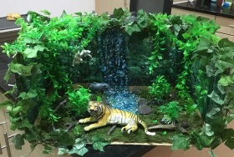  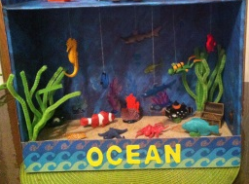 | Food is vital for athletes to thrive in their sports.  Create a 3D model of the digestive system.  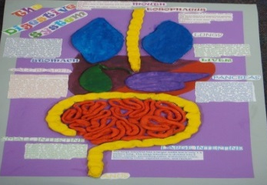  Show what happens to food after it enters our mouth and where it eventually ends up.
 | Should all children have to exercise?  Write a discussion that includes both sides of the argument.  You need to inlude the language of debate… | The Olympics began in Ancient Greece.  Create a timeline of the Olympic games and the athletes involved.  Be specific:  What year they competed  In which events?  What was their City-State?  and much more… | 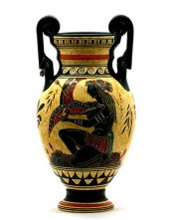  Greek pottery, the pottery of the ancient Greeks, important both for the intrinsic beauty of its forms and decoration and for the practically of their daily use.  Can you design one of your own?
  Many people believe… | On the other hand…
  We have various reasons for… | However…
  Our first reason… | Alternatively…
  Furthermore… | Whilst some people think…. Many also believe…
Homework is due on 20th March 2020

