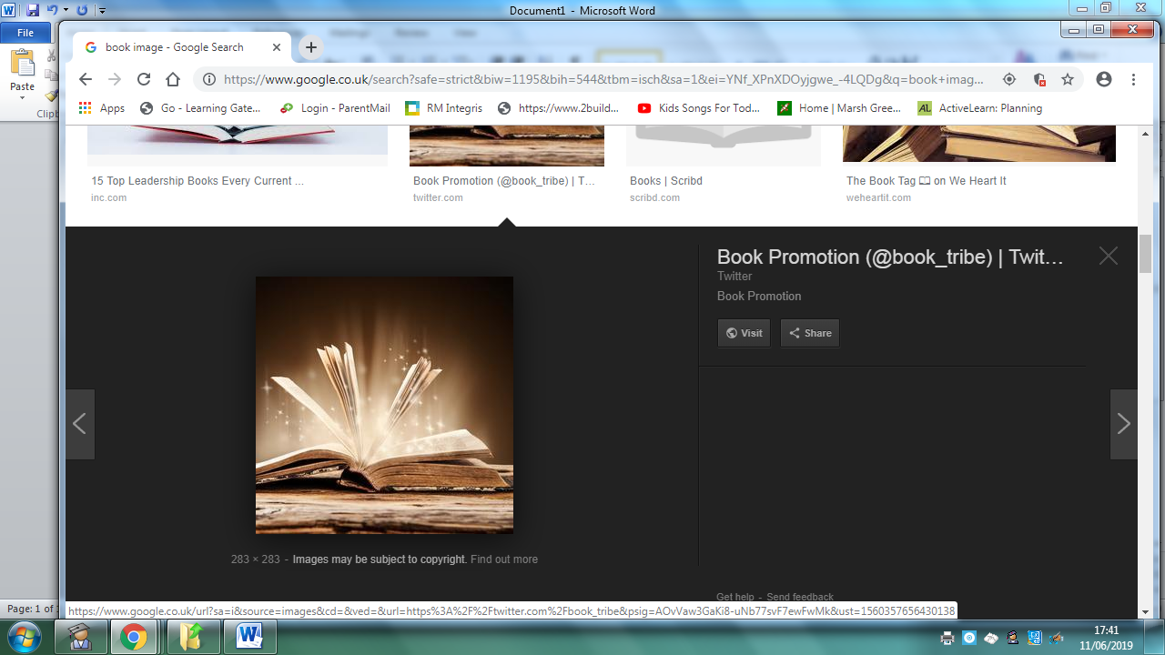
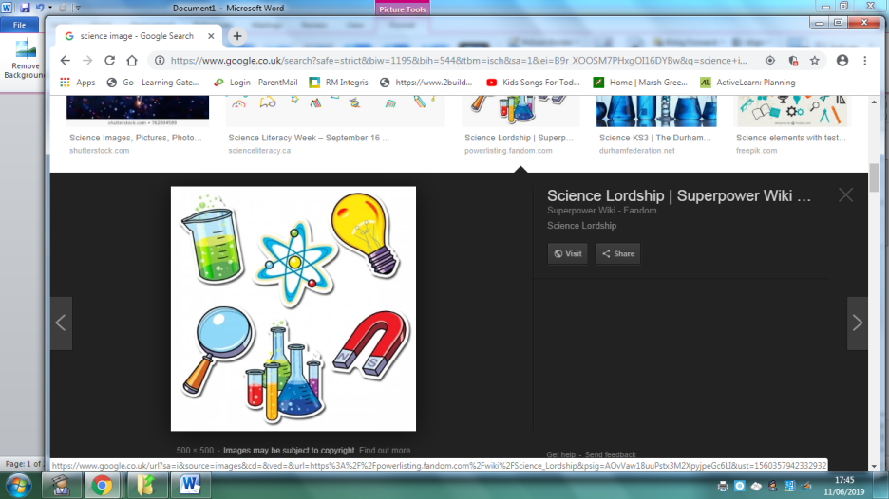
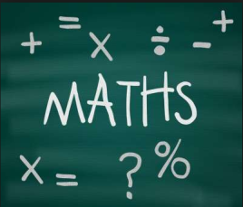
Homework
Year 6 Topic: Africa
 | Be a Writer | Be a Detective | Be an Artist
The children should choose a minimum of one task per section or more if they wish.  Children will be awarded house points and certificates upon completion of their projects.  Abacus homework on line. | Powerpoint  Create a powerpoint linked to everyday life in Ancient Benin.  This might include jobs, education, trade, food, clothing and jewellery. You can include pictures too by cutting and pasting.  Powerpoints can be shared in class. | Evolution (Science Link)  Research an African animal and write a brief report on how it has evolved.  What is their scientific name?  Who first discovered the animal?  Where does it live, what is its habitat like?  Draw an illustration of the animal and how it has evolved. | Martin Bulinya Artwork.  Using the style of Martin Bulinya, create your own piece of art. This can be painted, drawn or collaged.  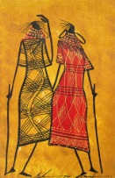
 | Write a biography about Charles Darwin or Carl Linneus. (Science Link)  Include key facts about their life and why they are famous.  You need: Formal language. Past tense. Joined handwriting. Relevant facts. | Ancient Benin.  Create a poster of Ancient Benin.  Include key facts such as– when the Kingdom was created, what life was like in the Kingdom, who were the rulers? | Rainforest Diorama.  Create your own rainforest. Research rainforests around the world. You will need: a shoebox, paper and glue.  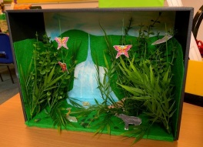
 | Write a first-person diary entry as a child in the Ancient Kingdom of Benin. What roles did boys and girls have? Consider this when you write.  You need to inlude…  -Date  -‘Dear Diary…’ to start  -First line summary ‘Today has been scary…’  -Chatty style  -First person ‘I’  -Past tense  -Questions  -Hopes for the future | Ancient Benin.  Create a timeline of key dates and events for the Ancient Kingdom of Benin. You will need a ruler and paper to create a timeline.  www.bbc.co.uk/bitesize/ks2 Under the history section and World History you will find out all about the Kingdom of Benin. | African Landscape  www.InsideAricanArt.com  Look at the range of African artists and their art. Recreate your own African landscape.  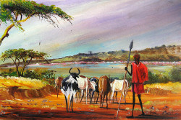
Homework is due on or before November 22rd 2019

