11.01.21
Today we are learning to to add a 1-digit number to a 2-digit number to reach the next multiple of 10

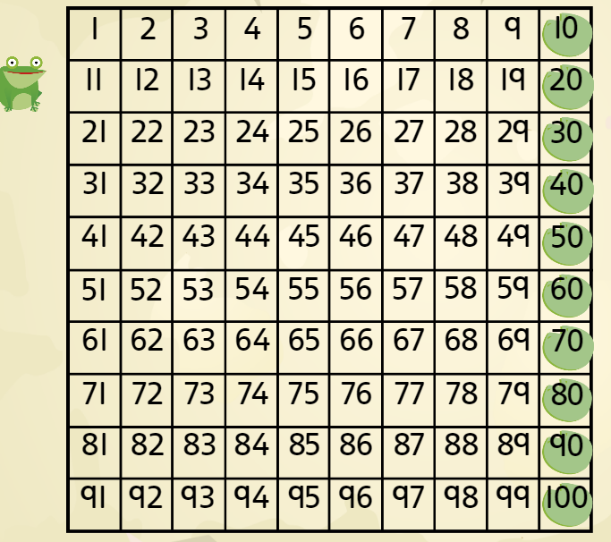

- 27 + __ = 30
- 72 + __ = 80
- 65 + __ = 70
- 23 + __ = 30
- 48 + __ = 50
- 34 + __ = 40
- 12 + __ = 20
- 99 + __ = 100
- 51 + __ = 60
- 86 + __ = 90
Extension:
Adding a 1-digit number crossing the 10s

Example:
34 + 8 =
Write the addition (34+8 = __)
Add to the next 10 (34 + 6 = 40)
Add the rest to this number (40 + 2 = 42)
34 + 8 = 42

Now try:

- 33 + 9 =

- 56 + 8 =

- 65 + 7 =

- 88 + 9 =

- 92 + 9 =

