Tuesday 5th January
L.I: Convert between multiples of 100 g and kilograms.

Starter:
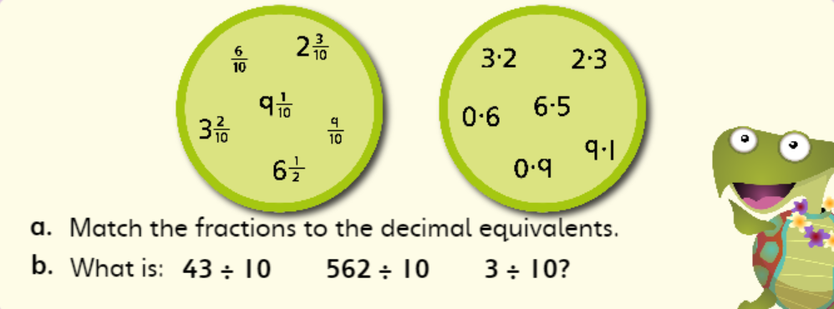
Weight
When we discuss the weight of some objects, the unit of measurement can be in grams (g) or kilograms (Kg).
1000 grams = 1 Kilogram or (1000g = 1Kg)
500g = ½ kg or 0.5kg
100g = 0.1kg
Can you convert the following grams into Kilograms?
1) 200g 5) 2500g
2) 300g 6) 3700g
3) 800g 7) 4600g
4) 1400g 8) 4900g
Can you convert the following Kilograms into grams?
1) 0.3kg 5) 2.1kg
2) 0.5kg 6) 7.6kg
3) 0.9kg 7) 11.3kg
4) 1.1kg 8) 18.4kg

Extension
Using some scales, can you weigh some items in your own home?
Here are some examples to get you started, you may wish to add your own:
- A piece of fruit
- A pen
- A piece of paper
- A cup
- A pan
Make a note of them all in grams.
Can you convert these into kilograms?

