Year 4 Spellings
Can you create sentences using your Year Four words?
Accident
Centre
Experience
Importance
Ordinary
Task 

Tricky - Create a simple sentence with each word
Trickier - Create a simple and compound sentence using each word
Trickiest - Create a simple, compound and complex sentence using each word

Don’t make it boring! 
Use adjectives and other interesting word choices. Use a wide range of punctuation.
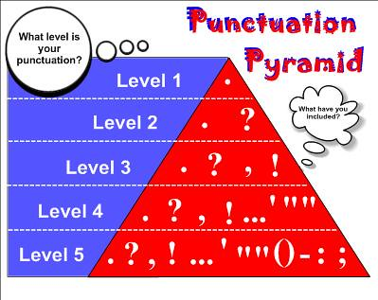
Extra Support:
Use this game to practice your spellings http://www.ictgames.com/littleBirdSpelling/

