NEWSPAPERS

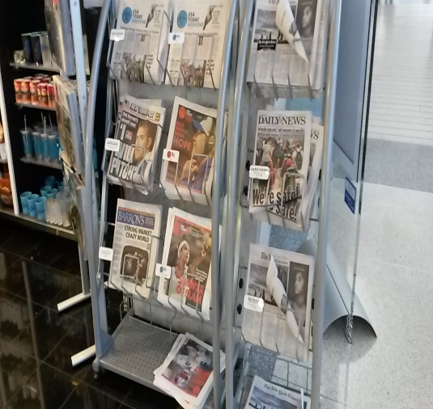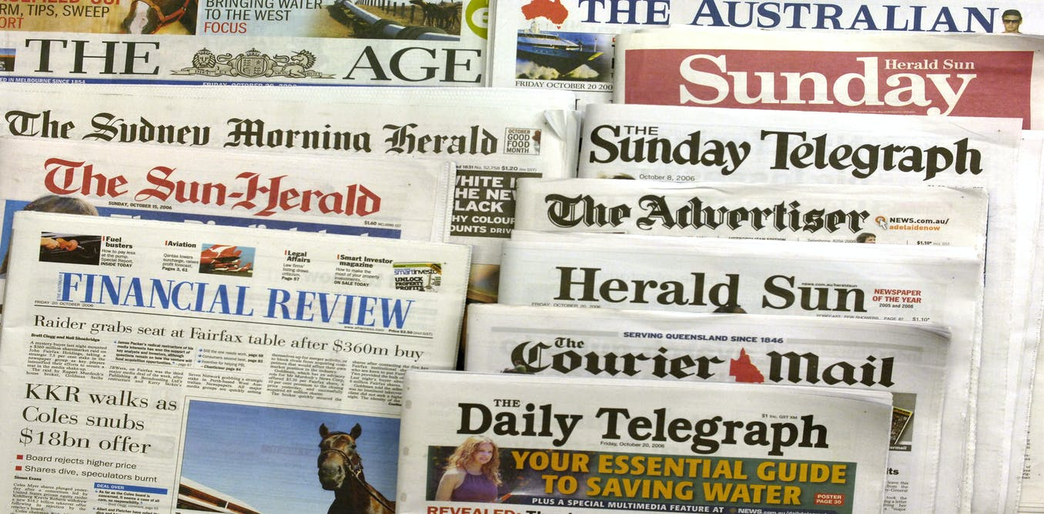

This term we will be learning all about newspapers! This is because we will eventually write our own newspaper about our new topic.

What I would like us to do first is to get a feel for what a newspaper reads like. This will help us to learn the style of writing that we will be requiring you to write in.

Task

All: Go onto the following website https://newsforkids.net/ read at least 3 different articles that catch your attention. Complete the responding grid below about one of your articles (You can draw out the sheet in your book).

Extra Support: Please use the following website to locate your articles https://www.bbc.co.uk/newsround

What I liked about the article  | What I disliked about the article  
Questions I have about the article   | What puzzled me  

