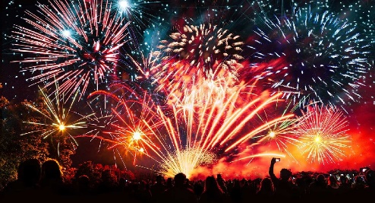
Tuesday 5th January
L.I: To understand how the new year is celebrated.
New Year’s Eve
New Year’s Eve is celebrated on December 31st, the last day of the calendar year.
People enjoy getting together with family or friends and counting down the hours, minutes, and seconds to the start of a brand-new year. You might even be allowed to stay up extra late!
In London, the Big Ben chimes to tell us when the new year has arrived (at midnight), then a huge firework display takes place on the banks of the River Thames. This is to celebrate the end of the year and the beginning of a new year.
Below is the video of the new year countdown in London. Please watch this whole video and think about what happened across the world in 2020.
https://www.youtube.com/watch?v=MpJIg_3DnLk

New Years Resolution
New years day is on January 1st and is seen by many people as a ‘fresh start’.
Many people like to make new years resolutions. These are personal goals that they aim to achieve throughout the year.
Anyone can make a new year’s resolution and some people make more than one.
Here are some examples:
- Getting homework in on time.
- Keeping your bedroom tidy.
- Doing more exercise.
- Eating healthy.

Task
Your task is to think of a new year’s resolution for yourself.
Answer the questions on the next page in full sentences.

1) What is a new year’s resolution?
2) What is your new year’s resolution?
3) Why have you chosen this new year’s resolution?
4) How will you achieve this goal?
5) How will this make you a better person?

