Thursday 6th January 2021
LI: To learn about the 5 W’s
Newspapers
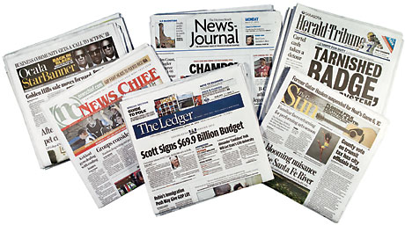

- Recap on our learning so far by visiting the website below. Read the information about the features of newspapers and play the ‘label the feature of the newspaper’ game.

https://www.bbc.co.uk/bitesize/topics/z2yycdm/articles/z2gk9qt

- All newspaper articles have the 5 W’s. But what are the 5 W’s? Watch this video to find out more! https://www.youtube.com/watch?v=PynWuU3BX4E

- Read the following information on the 5 W’s just to check that you fully understand what they are and why they are used.

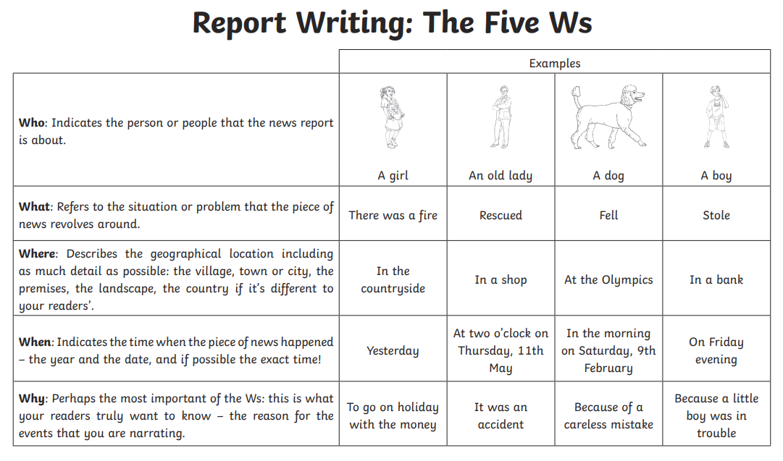
- Look at the box below. Create your own opening using the 5 W’s. Tip, choose one sentence from each section. Finished? Create a picture to go along with the opening that you have written.


