Thursday 6th January 2021
LI: To learn about the 5 W’s
Newspapers


- Read the information about the features of newspapers and play the ‘label the feature of the newspaper’ game.

https://www.bbc.co.uk/bitesize/topics/z2yycdm/articles/z2gk9qt

- All newspaper articles have the 5 W’s. But what are the 5 W’s? Watch this video to find out more! https://www.youtube.com/watch?v=PynWuU3BX4E

- Look at the example below of the 5Ws. Use the examples to create your own opening, and then draw a picture to go with what you have written.

Mrs Johnson’s Example –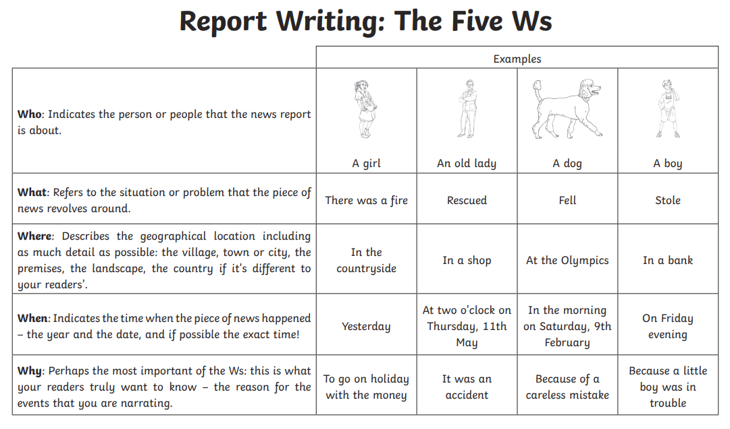
A local girl rescued a boy in a shop yesterday from bully’s that were trying to take away his pocket money. The boy was in much trouble until she stepped in and saved the day!

Opening-
____________________________________________________________________________________________________________________________________________________________________________________________________________________________________________________________________________________________________________________________________________________________________________________________________________________________________

Drawing -

