Thursday 7th January
L.I: Measuring in millilitres and litres.

Today we are moving away from measuring weight in Grams and Kilograms.

We are now going to focus on measuring the volume and capacity of objects using litres (l) and millilitres (ml).

Just like grams and kilograms…
1000 millilitres = 1 litre or 1000ml = 1L
Capacity - the amount of liquid a container can hold.
Volume - how much liquid is in the container.
Read this page on BBC Bitesize about measuring in Litres and Millilitres.

Measuring in millilitres - Year 2 - P3 - Maths - Catch Up Lessons - Home Learning with BBC Bitesize - BBC Bitesize

Activity 1 – You are going to be a measurement detective!

Be your own measurement detective and work with a parent or guardian to find objects around your home which hold up to 1 litre, for example a bottle of water or a can of orange juice.

- Can you find a container that holds exactly 500ml?
- Can you find a container that holds exactly 1l?
- Which container holds the most?
- Which container holds the least?

Activity 2 –
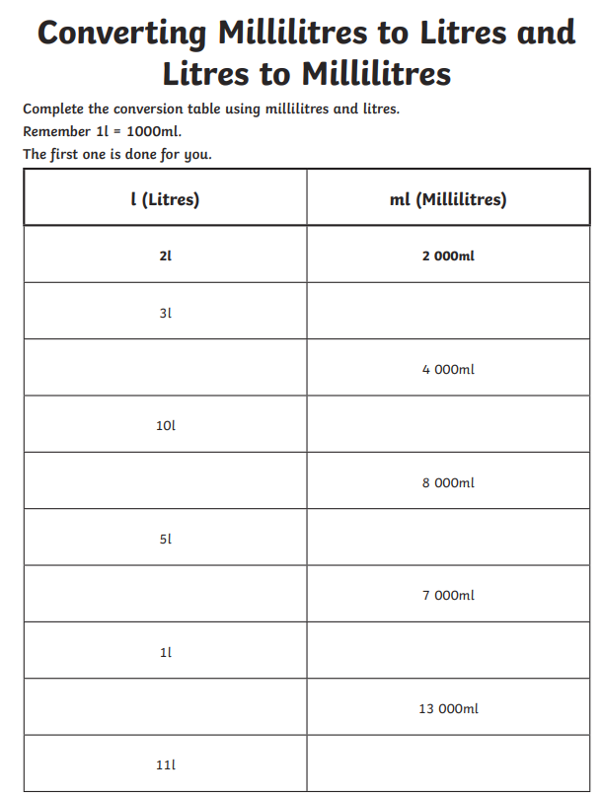
Dynamics

Activity 2 –
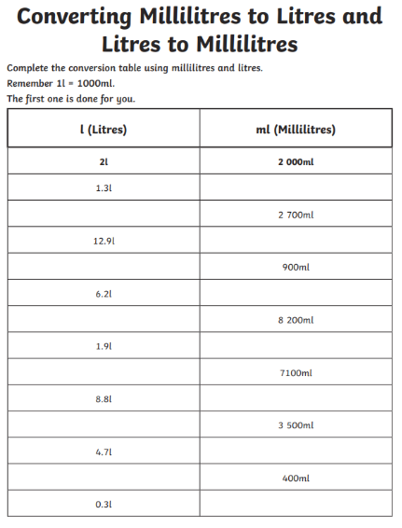
Magnificents and Explosives

Activity 3 – Extension
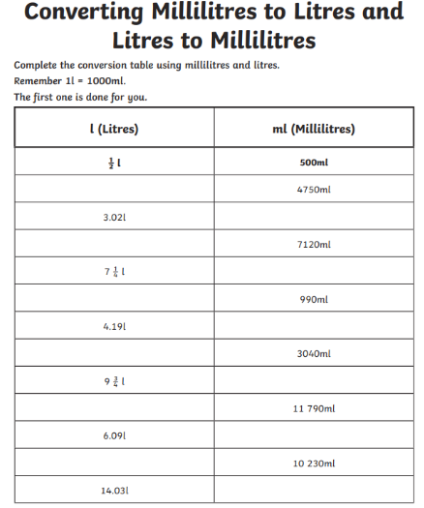
(Explosives and Magnificents only)

