Wednesday 6th January
L.I: To learn about incredible sports and their emotional benefits.

Below is a short video explaining some of the emotional benefits of exercise.
Benefits of Physical Activity on Mental Health 2019 - YouTube

Emotional Benefits:

Positive Body Image and Healthy Self-Esteem
Negative body image is especially prevalent in girls who are approaching their teen years.
The sense of accomplishment that comes with athletic competition also leads to a healthier sense of self-esteem (feeling good about yourself or a sense of achievement).
Stress Reduction and Positive Effects on Mood
Children who participate in sports can leave their stress and aggression on the playing field. This will reduce stress and lift your mood.

Mental Benefits
Regular participation in athletics can help to build young minds by requiring creative and strategic thinking, as well as increased focus and attention.
Not only that, but most sports involve some kind of scoring, which can help children to sharpen their mental math abilities. All of these skills translate not only to the classroom, but to the skills necessary in the workforce later in life.
Sportsmanship
In life, you win some and you lose some. Nothing brings this lesson home in early life better than participation in sports. Winning and losing is a part of life.

Activity 1:
Can you think of any other emotional benefits from playing sports or exercising regularly?
You may use the internet to research some other reasons.
Write them down as a list and explain why they are important. Make sure to write in full sentences.

Activity 2 on the next page

Activity 2:
For this activity you need to find a safe space in your home. This can be in your bedroom, living room or garden, just make sure you have some space.
Use the yoga exercise cards below and copy them. You can do this alone or encourage your family to join in.
You can choose any exercise that you want; you may even want to do them all.
You should aim to exercise for at least 20 minutes.
Time to feel some of those emotional benefits you have just learned about!
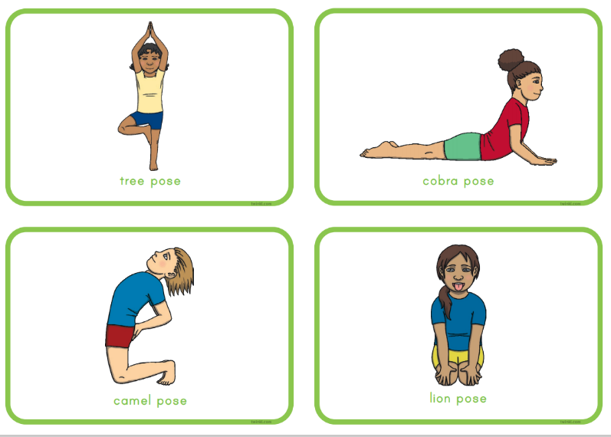
Remember, when doing yoga, you should clear your mind of any negativity and breathe slowly and deeply. Relax.


