Friday 8th January
L.I: Measuring in millilitres and litres.

Key words
Capacity - the amount of liquid a container can hold.
Volume - how much liquid is in the container.

Starter:
Can you put these measurements of water in order from smallest to biggest?

400ml, 1/2 litre, 100 ml, 0.3 litres, 900ml, 700 ml, 1 litre

Dynamics your task can be found on the next page

Explosives and Magnificents, please scroll down past dynamics work to get to your maths tasks.

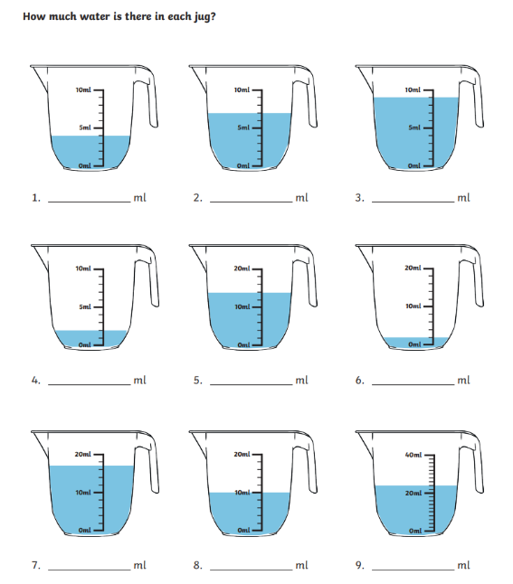
Activity 1 - Dynamics

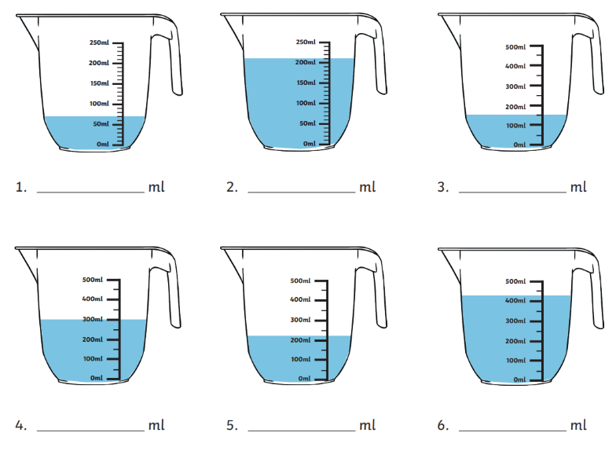
Activity 2 – Dynamics

Activity 1 - Explosives and Magnificents – Let’s put your new knowledge to the test!

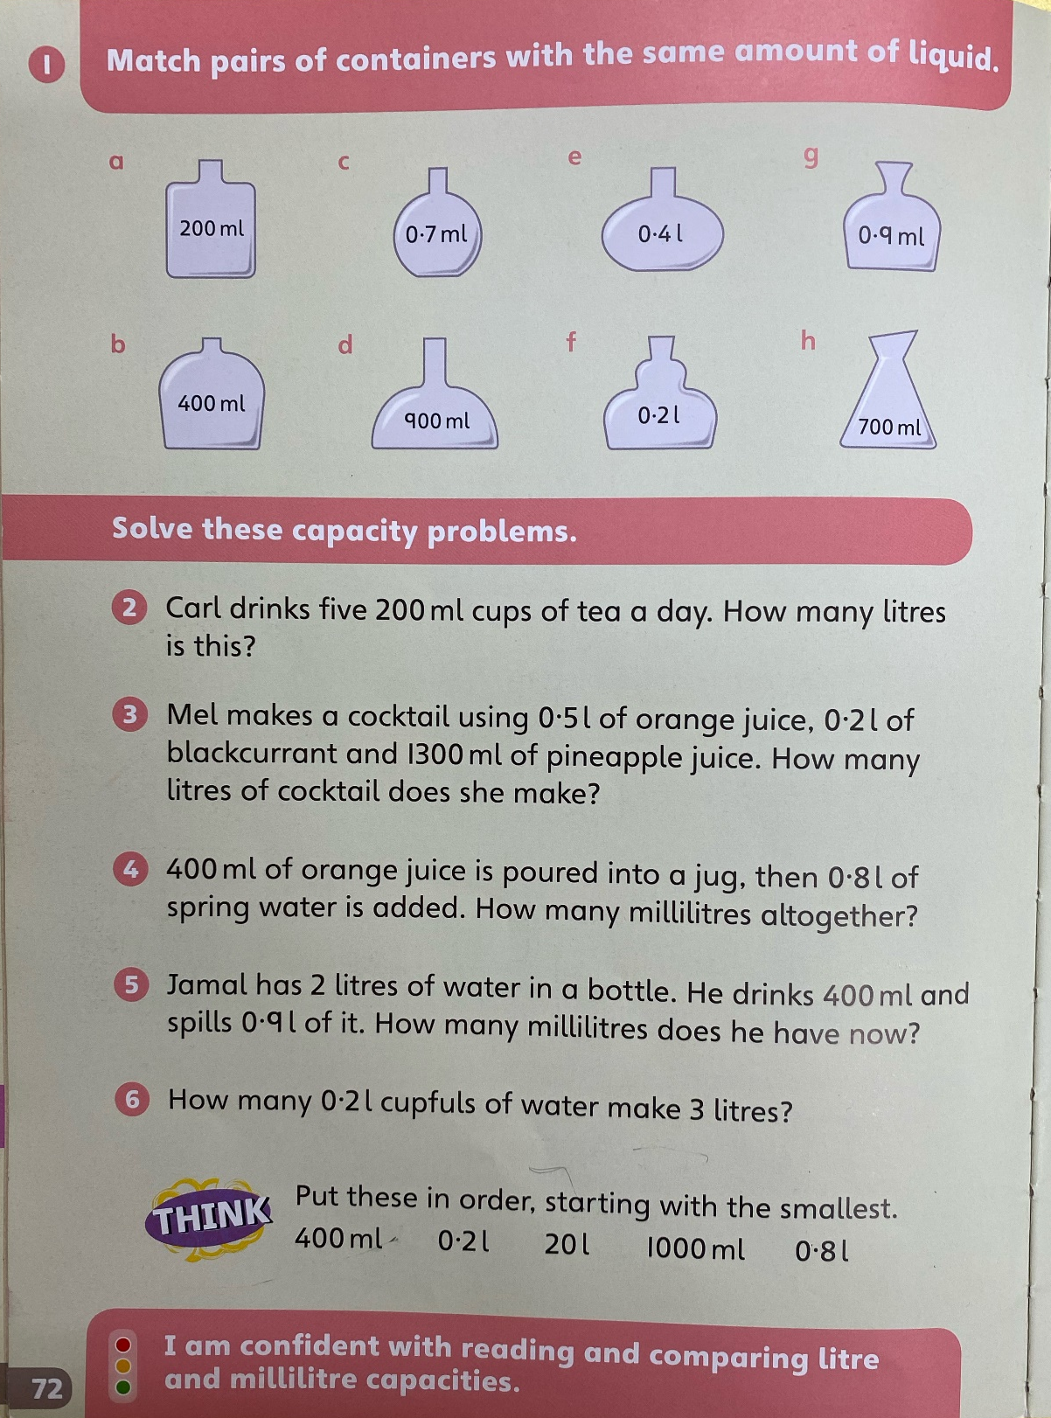

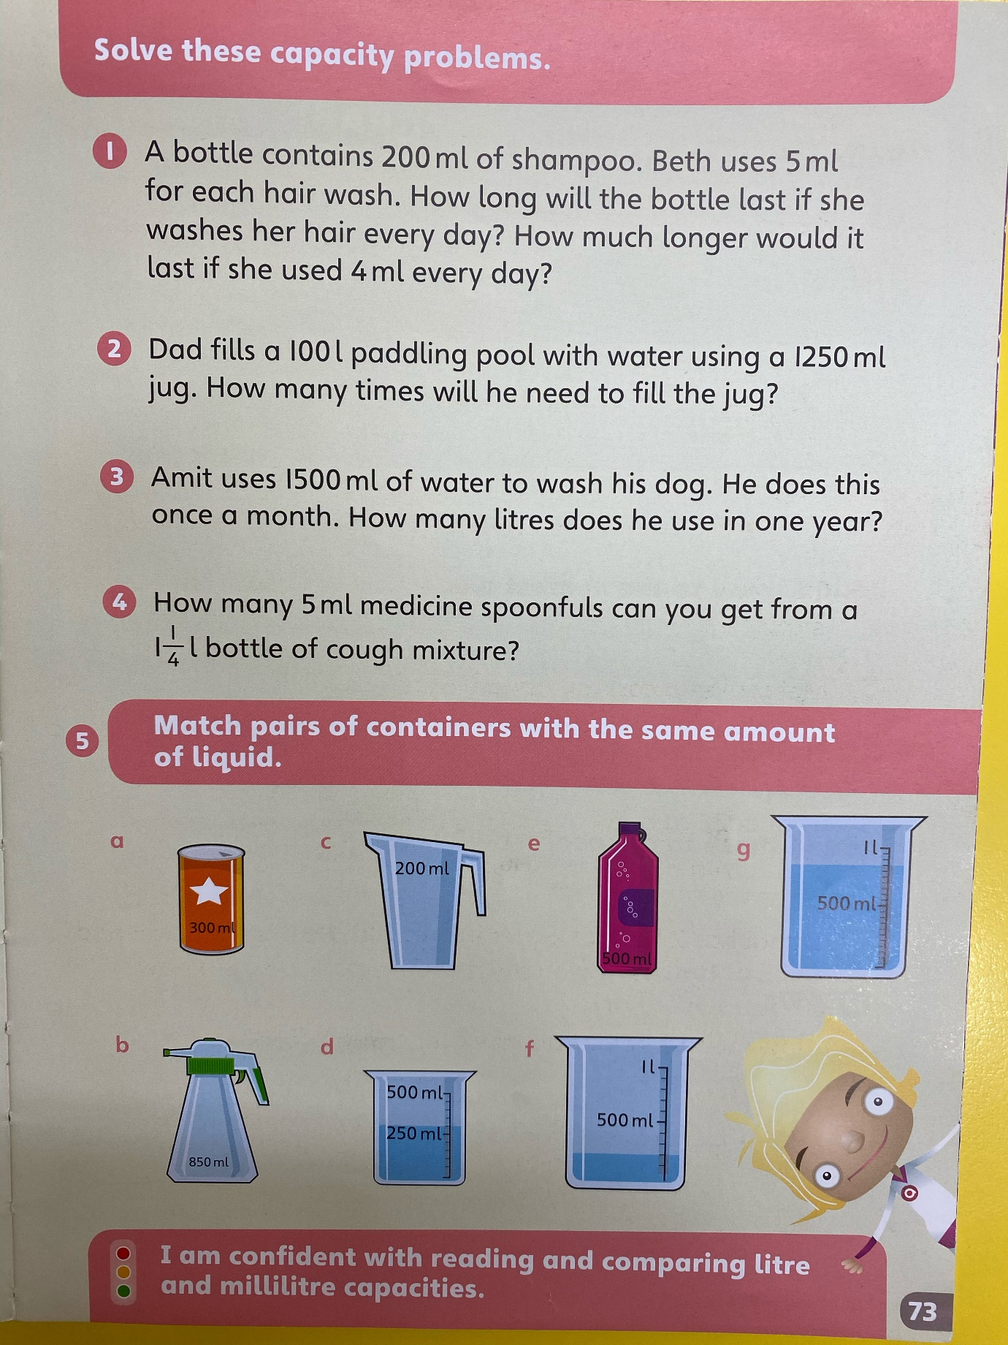
Activity 2 - Explosives and Magnificents – extension

