Friday 8th January
L.I: To create your own ‘unusual’ sport.

Over the last few lessons we have been learning about the physical and emotional (mental) benefits of exercise.
Your task for today is to create your own ‘unusual sport’.

Activity 1:
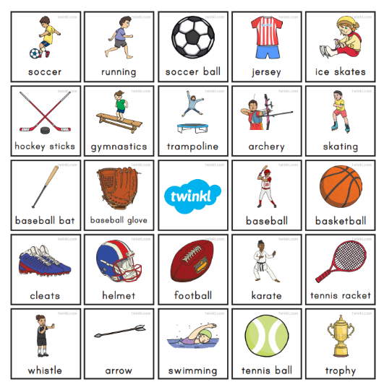
Use the diagram below to give you some inspiration of some sports.
You could combine two or three sports together to create a new sport.
For example, you could create a sport using archery and skating.
Players must fire an arrow at a target whilst skating on ice!

Try to come up with your own unusual sport. You may use the pictures or even another sport that you can think of, the choice is yours.

Activity 2: Draw a picture of this sport in action and make a name for it!
Activity 3: Draw a table and list the physical and emotional benefits of your new unique sport.
Icey archery
Physical | Emotional

