Can you find the features of a newspaper article?
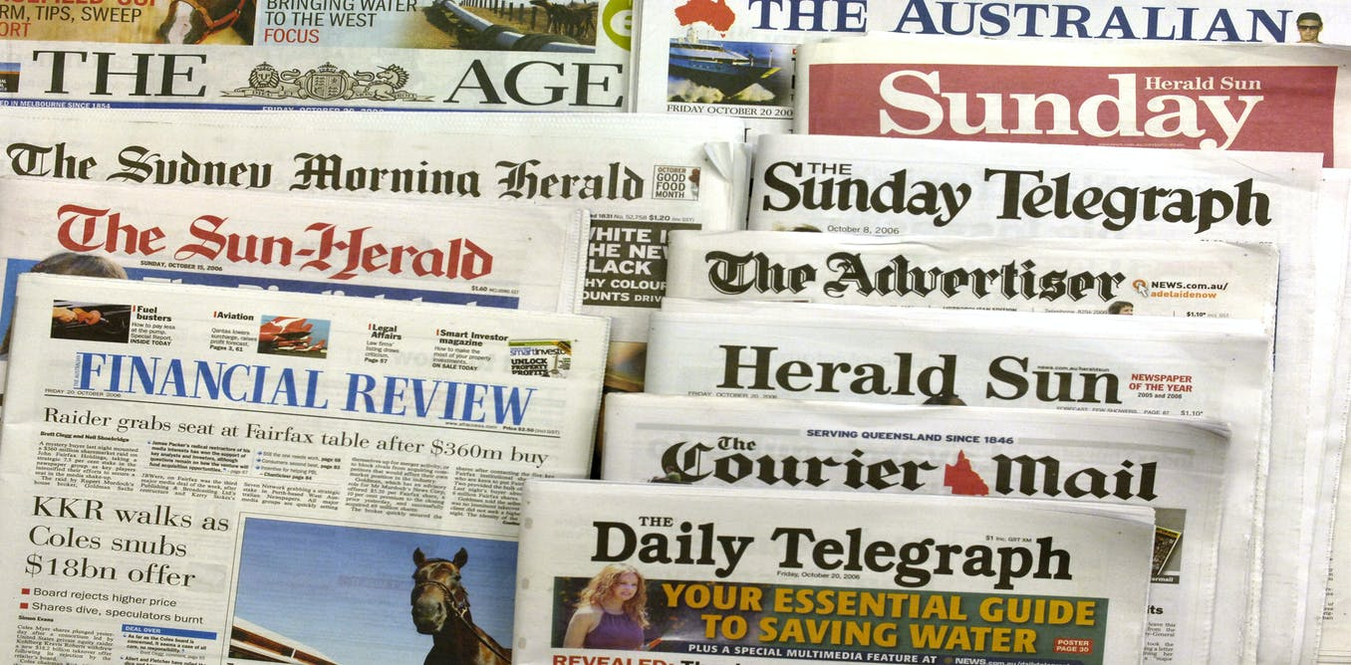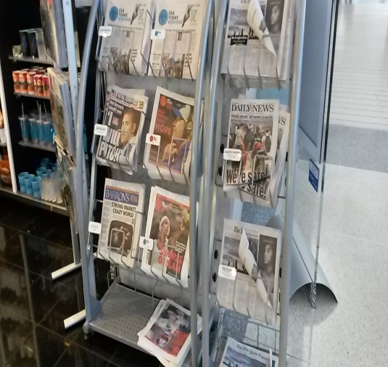
Newspapers have a particular layout. You will find these features on a newspaper article
Caption – A label for a picture in a newspaper article
Headline - A heading at the top of an article or page in a newspaper or magazine
Opening –The beginning of the newspaper article
Paragraph - Paragraphs help to structure text; every new paragraph starts on a new line. We start a new paragraph to signal that the person, place, time or topic of the sentences has changed.
Quote - Words from a text or speech written or spoken by another person
Past Tense - A tense expressing an action that has happened
Task:
- Read through the article below
- Draw a small list from number 1 to 7. Beside each number write down the feature you see (make sure you are matching it with the green labels…)
- EXT- Identify the powerful verbs in the article, can you write them down into sentences of your own?



