Comprehension Activity
- Read the newspaper article
- Answer the questions below (write your answer on a piece of paper)
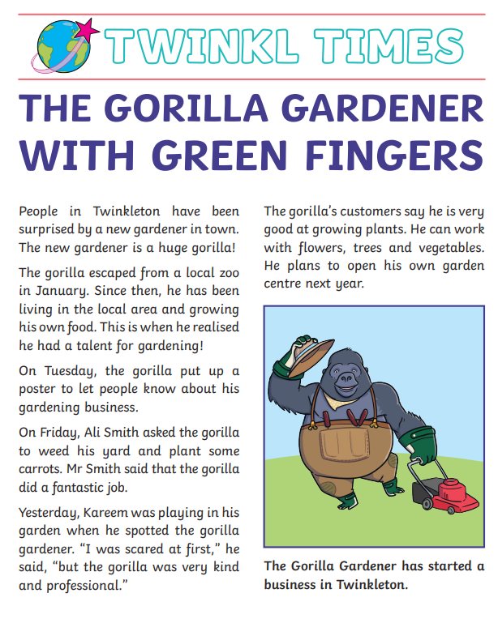
- What is the article called?
- When did the gorilla escape from the local zoo?
- What did the gorilla realise he had a talent for?
- Was Mr Smith happy with the gorilla’s work?
- Was the gorilla plan to do next year?

