Wednesday 6th January
L.I: How to measure the mass of different objects.

Read this page on BBC Bitesize about measurement, it will reinforce everything that you learnt yesterday.

Measure mass in grams - Year 2 - P3 - Maths - Catch Up Lessons - Home Learning with BBC Bitesize - BBC Bitesize

Once you have read this, complete the quiz on activity 1.

Activity 2 can be found on the page below.

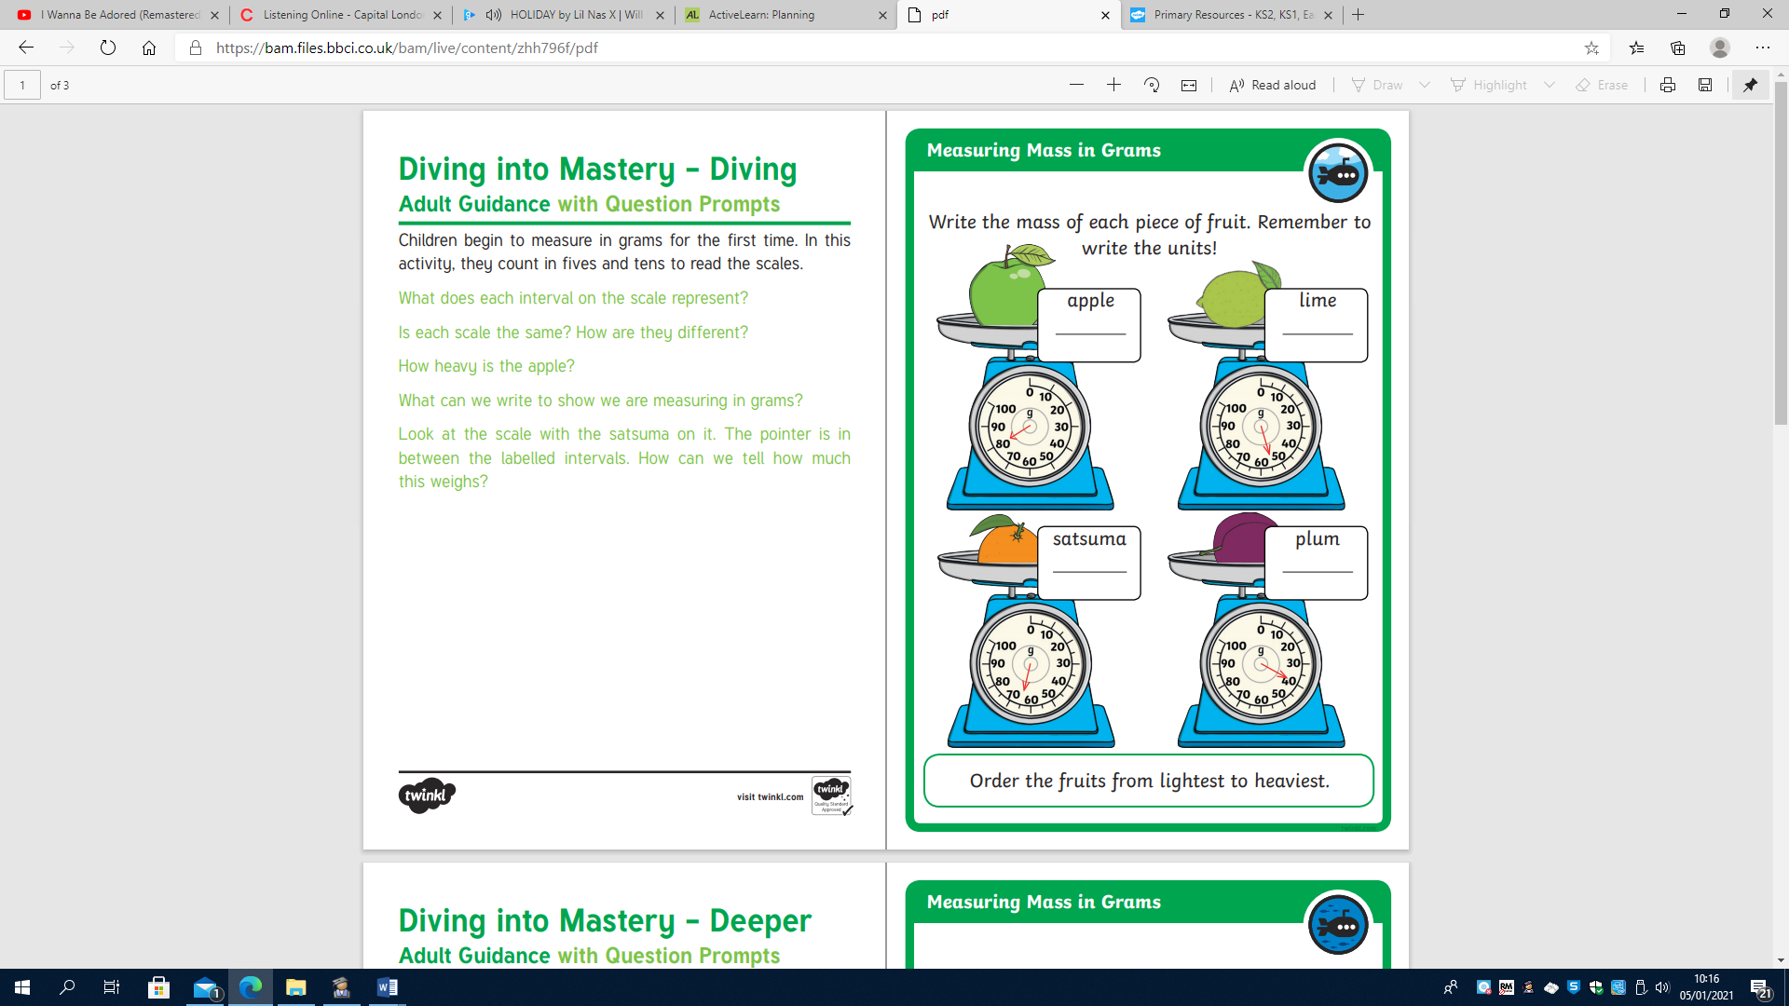
Dynamics
Explosives and Magnificents


