Wednesday 13th January 2021
LI: To use alliteration
Newspapers

Watch the following video on alliteration, https://www.youtube.com/watch?v=5_b845Lxtq4
Now read the following explanation about alliteration
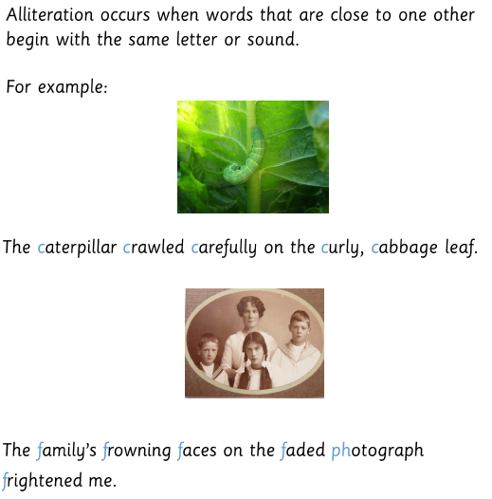

In your own words write down an explanation of what alliteration is. Can you include an example to back up your explanation?

My explanation of alliteration:
________________________________________________________________________________________________________________________________________________________________________________________________________________________________________________________________________________________________________________________________________________________________________________________________________

Examples of alliteration in real newspapers –





