13.01.2021
L.I: To use methods for addition.

Starter:
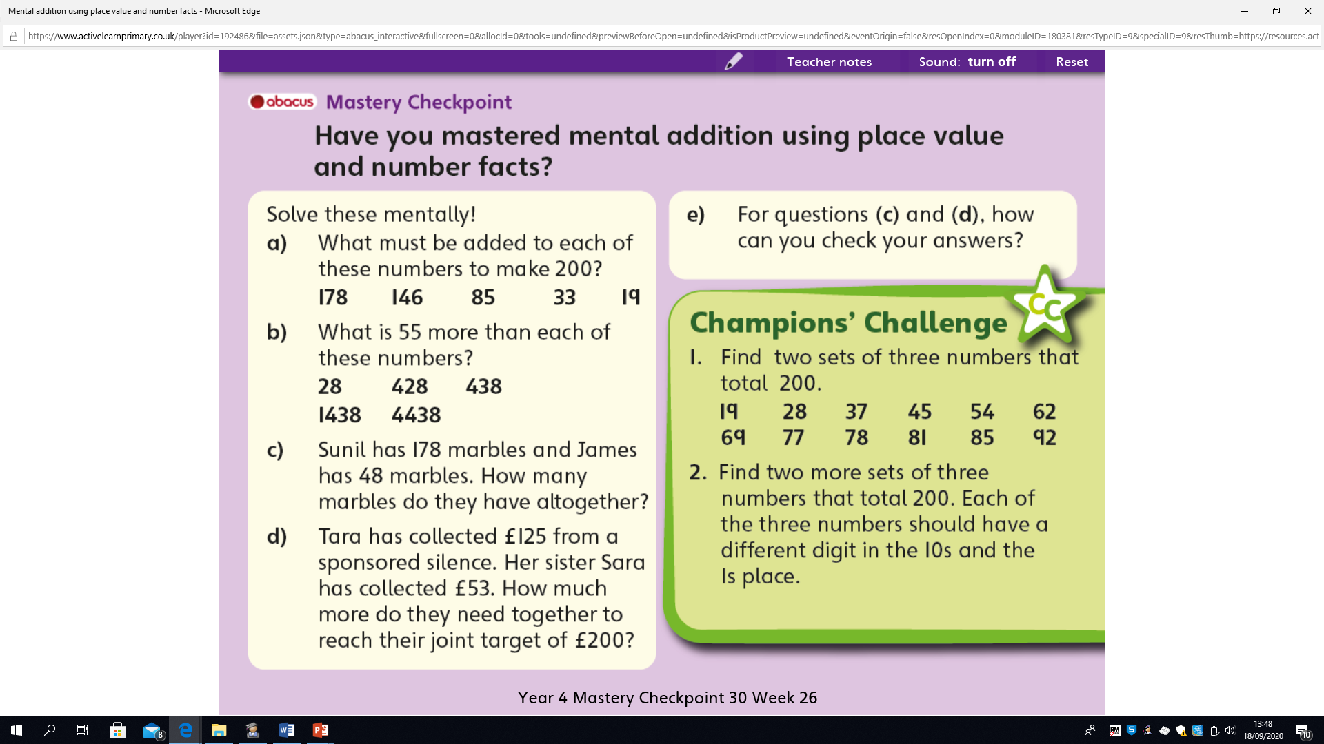

Today we are going to focus on the compact column method for addition. This is very similair to the expanded column method.
However, we are compacting (making our calculations more dense/compact).

For example: 234 + 347 =

Expanded column method Compact column method

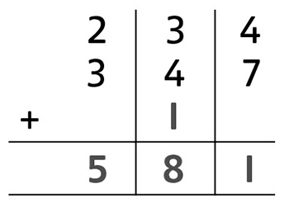
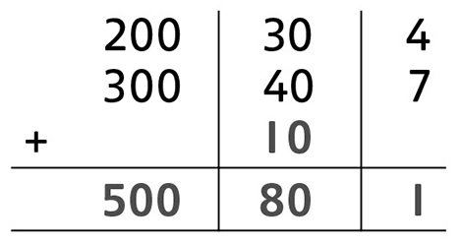

Can you see the difference?
Using the expanded column method helps us to see the digits (Hundreds, Tens and Ones).
This might take longer to write down but it is one way of reasurring that we are working eveyrthing out correctly.
Once you have practiced this method enough it becomes simpler and quicker to move onto the compact column method. This requires a little more of your mental addition.
You may choose which ever method to help you with your working out.

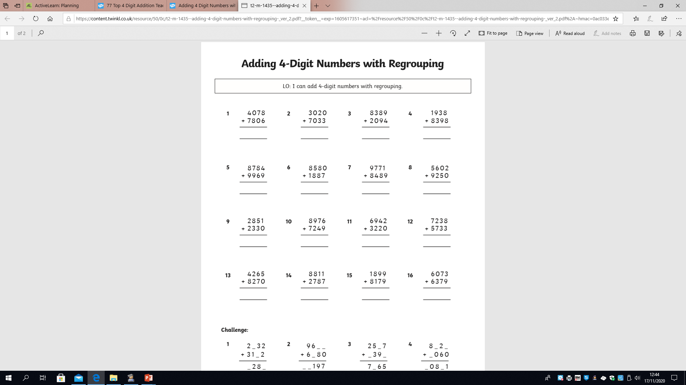
Let’s see if you can use the compact column method to solve the folllowing.

