13.01.2021
L.I: To use methods for addition.

Activity 1)
Solve these addition problems to the nearest ten. The first one has been done for you.

Use the number square below to help you with your counting!!

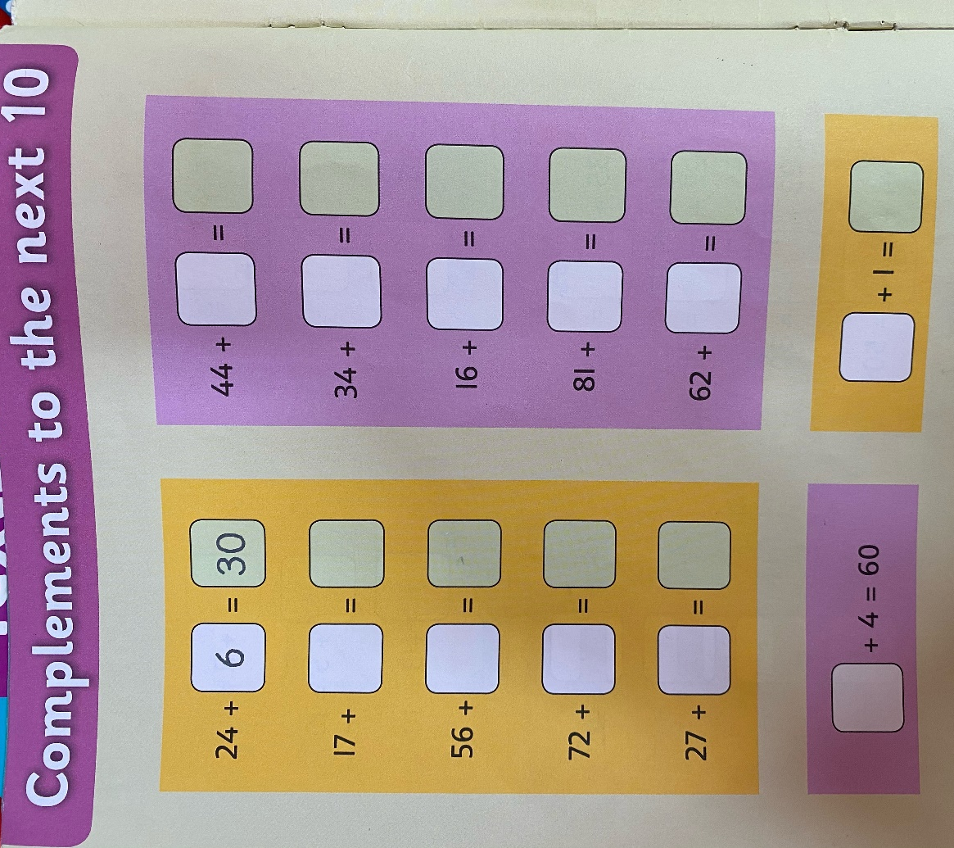

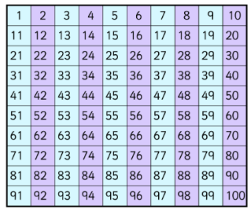

Activity 2)
Can you solve these additions using the expanded column method?

- 17 + 13 =
- 12 + 22 =
- 21 + 13 =
- 38 + 21 =
- 53 + 26 =
- 23 + 14 =
- 34 + 15 =
- 81 + 18 =

