Wednesday 13th January 2021
LI: To generate questions
The Greeks loved sport and the Olympic Games were the biggest sporting event in the ancient calendar.
The Olympic Games began over 2,700 years ago in Olympia, in south west Greece. Every four years, around 50,000 people came from all over the Greek world to watch and take part. The ancient games were also a religious festival, held in honour of Zeus, the king of the gods.
There were no gold, silver and bronze medals. Winners were given a wreath of leaves and a hero's welcome back home. Athletes competed for the glory of their city and winners were seen as being touched by the gods.

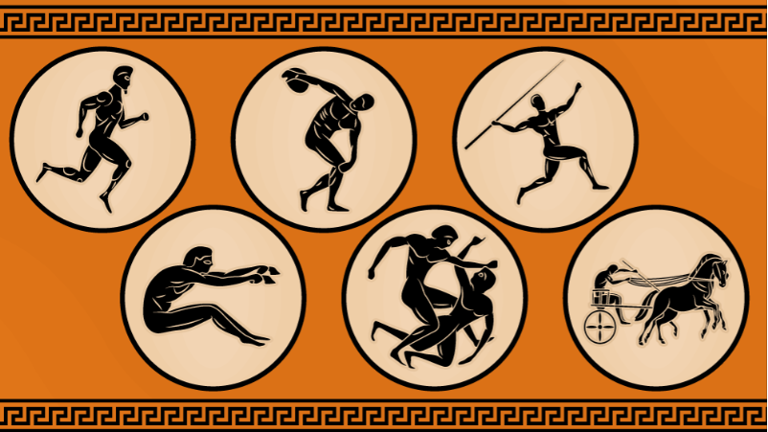
Be a history detective

Study these pictures, what sport does each picture depict?

Word bank: Javelin throwing, horse-riding, running, wrestling, long jump, discus,
Sport
1
2
3
4
5
6

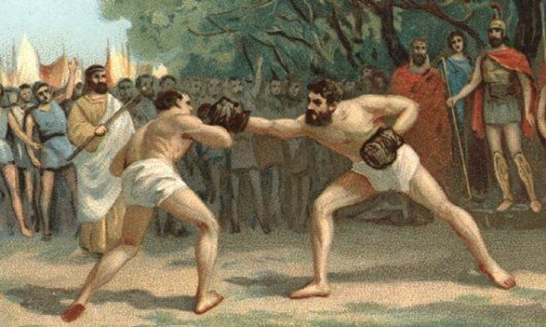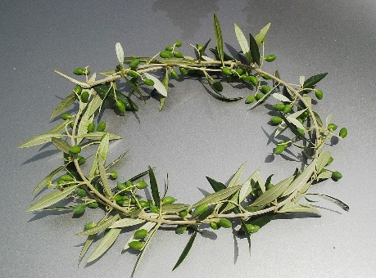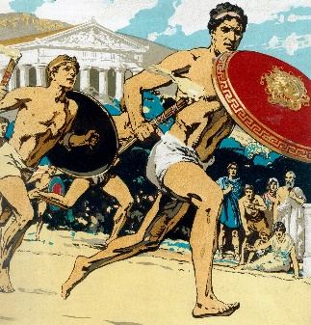

Task
What do you want to find out about the Ancient Olympics?
Can you generate questions about the ancient Olympics?

Examples
What happened at the first Olympic games?
What sports were involved in the Olympics?

