12.01.2021
L.I: To master the expanded column method.

Starter
Can you partition these numbers?

165, 247, 953, 4012, 3069, 9613, 728, 8763

Can you write those numbers in order from largest to smallest?

Activity 1)
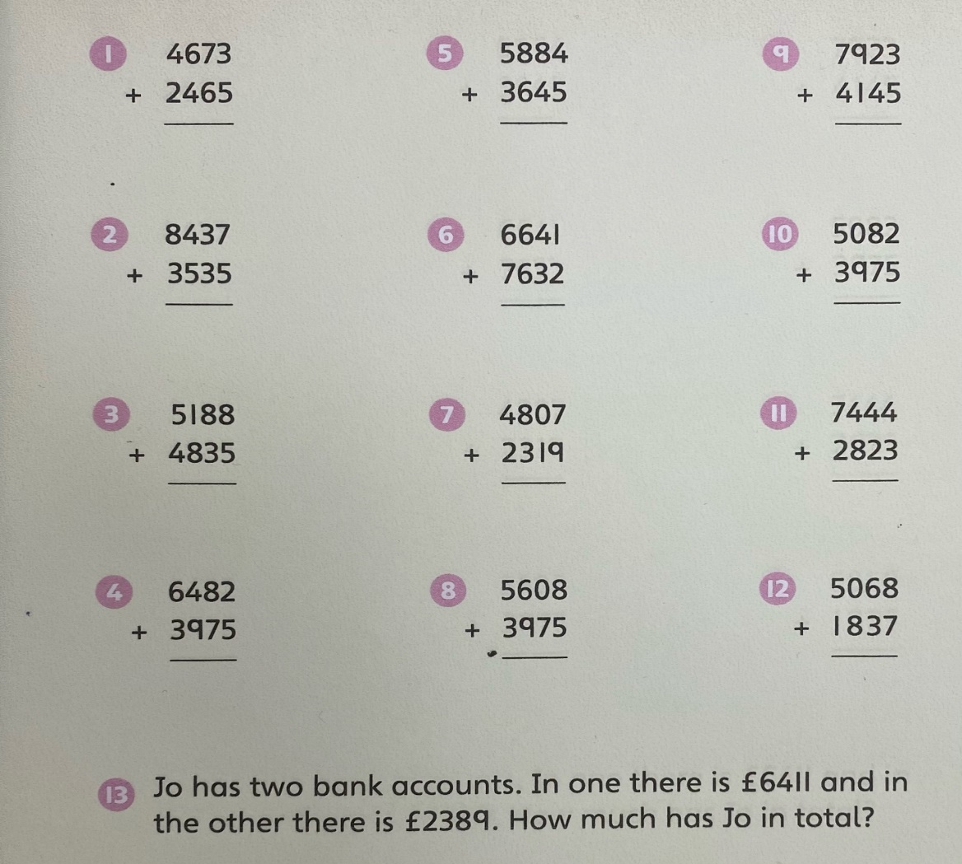

Activity 2)


