12.01.2021
L.I: To use addition methods.

Starter: Can you partition these numbers into tens and ones?

12, 32, 84, 95, 99, 70, 58, 47

Can you put these numbers in order from largest to smallest?

Expanded column method

Below is a reminder on how to do the expanded column method.
Remember to follow these 4 basic steps to help you solve addition!
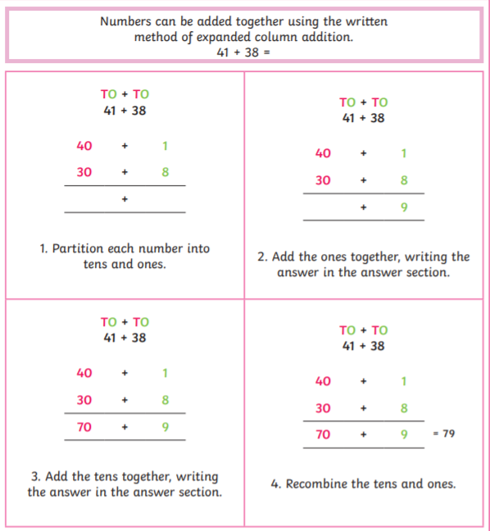

Activity: Adding two-digit numbers.
Can you solve these addition questions using the expanded column method?


