Tuesday 12th January 2021
LI: To know the difference between direct and indirect speech
Newspapers

Watch the video on direct and indirect speech
https://www.youtube.com/watch?v=pGOYlbXbN0o
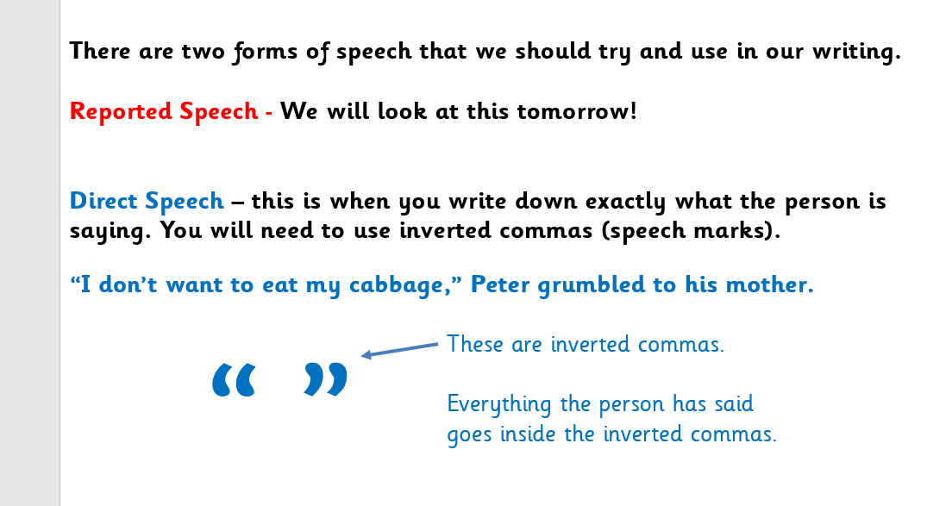

In newspapers you will find both reported and direct speech!

Task
Copy each sentence down and write down next to it whether it is direct or indirect speech
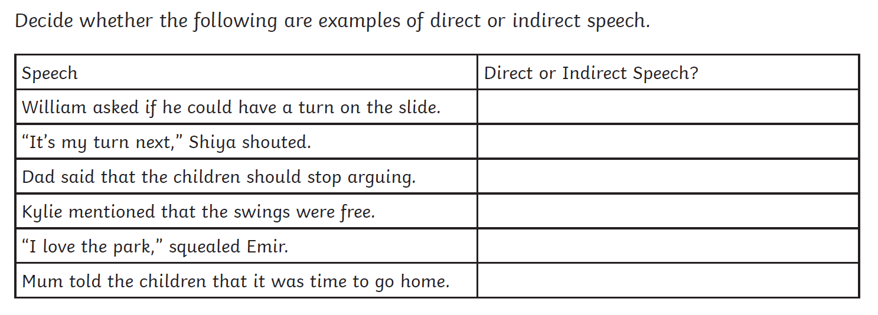
Write out these sentences including direct speech punctuation
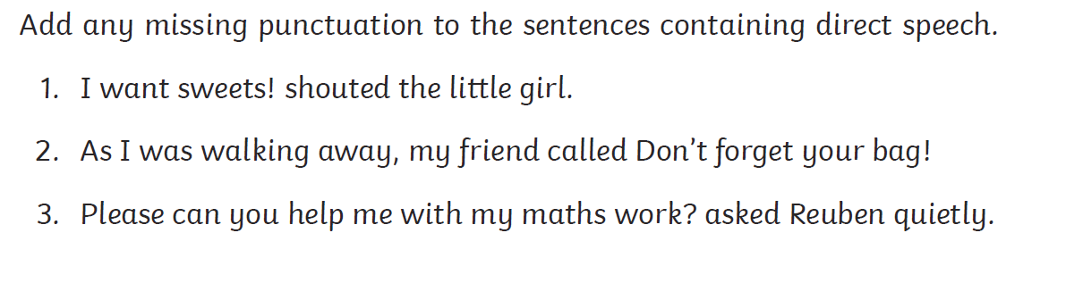
Can you change direct speech into indirect speech? For example
Direct speech: “Let’s watch the movie together,” suggested Ben.
Indirect speech: Ben suggested we watch the movie together


