Tuesday 12th January 2021
LI: To know the difference between direct and indirect speech
Newspapers


In newspapers you will find both reported and direct speech! Look at the example below. What differences do you notice?
Indirect Speech

Ben asked mum for the red block.
Direct Speech
“Can I have the red block please?” asked Ben.

Task
Copy each sentence down and write down next to it whether it is direct or indirect speech
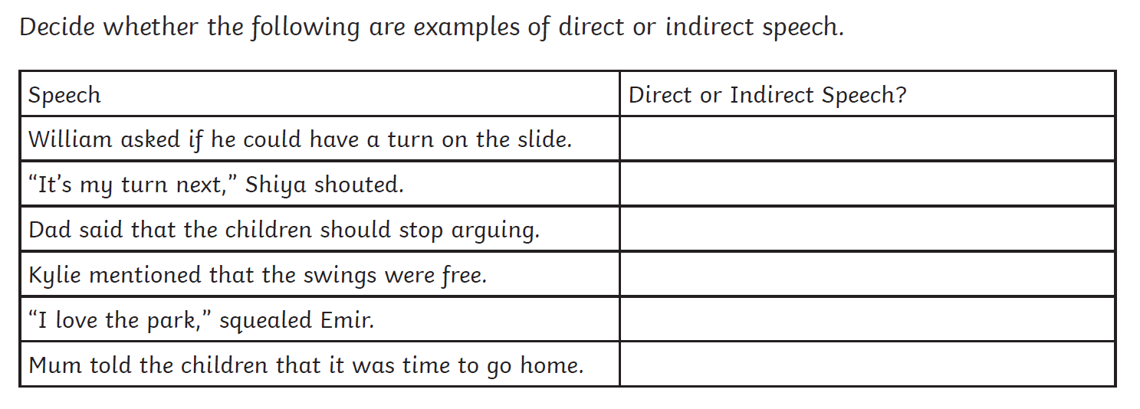
Write down a Direct Speech and Indirect Speech sentence to go with the picture. Remember to use inverted commas “ “ and speech punctuation (.?!,)

Indirect Speech

____________________________________________________________________________________________________________________________________________________
Direct Speech
____________________________________________________________________________________________________________________________________________________

