Tuesday 12th January 2021
LI: Who were the ancient Greeks?
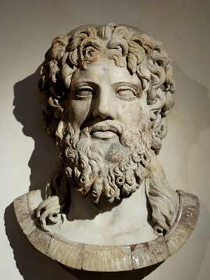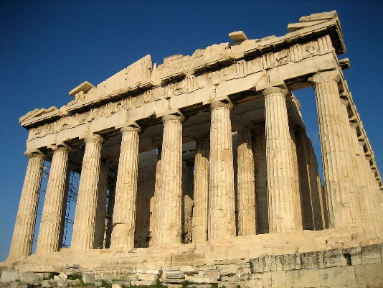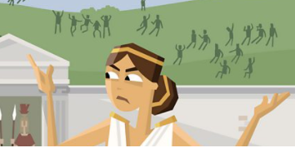

This term we will be learning about the Ancient Greeks. Get your brain warmed up by watching this video
https://www.youtube.com/watch?v=RchSJSJAbc0

Task
Read the information on the following website https://www.bbc.co.uk/bitesize/topics/z87tn39/articles/zxytpv4

Using the information from the site, answer the following questions in full answers.
1) What did the Greeks call themselves?
2)Name some other countries that Greeks lived in?
3) What was the first Greek Civilisation called?
4)When did Greece enter a golden age?
5)How was Ancient Greece ruled?
6) What was special about Alexander the Great
Ext activity – Game
https://www.bbc.co.uk/bitesize/topics/z7nrydm/articles/z2ngf82


