Thursday 14th January
Lets see if you can find the words you have been spelling this week!
If you don’t have a printer then not to worry! You can simply cut out some shapes and stick them with blue tak over your screen once they are done.
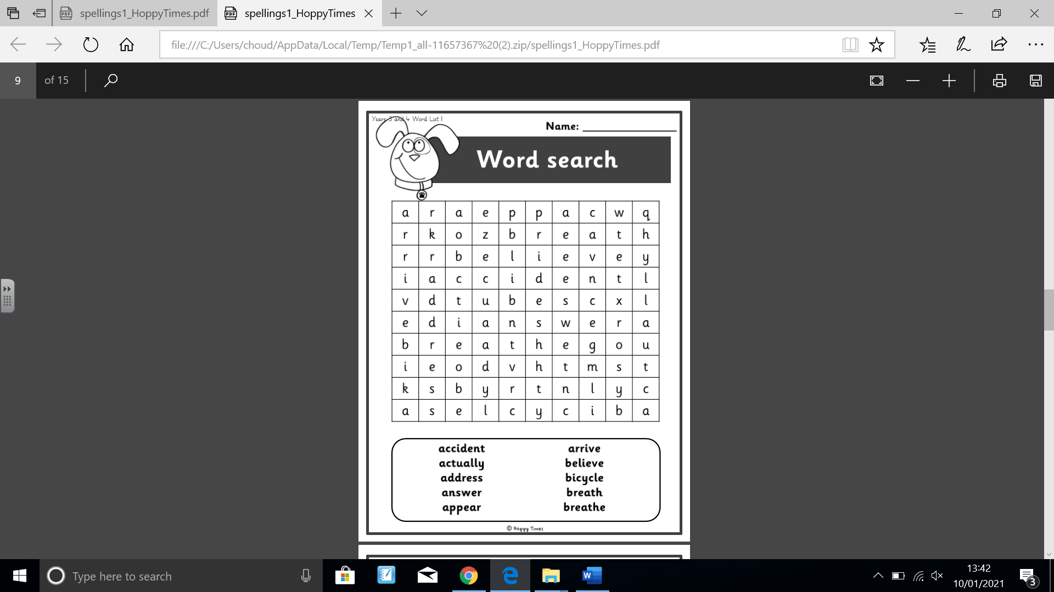
Or you can use the highlighter or drawing tool to colour them. Good luck!

