Thursday 13th January 2021
LI: Paragraphing
Newspapers
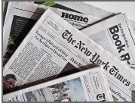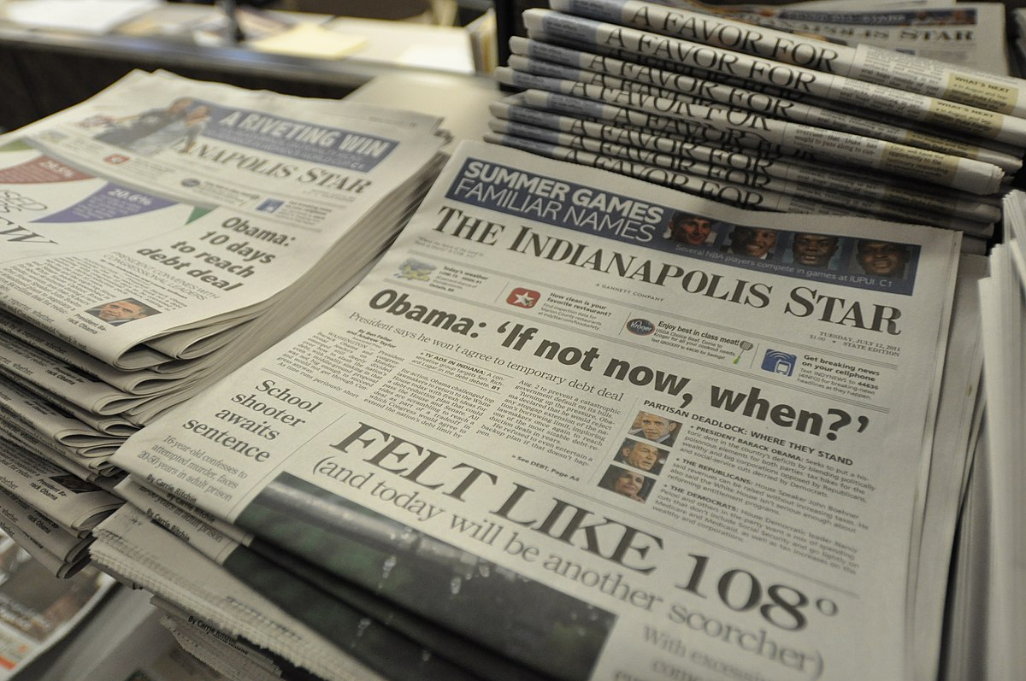

Newspaper articles are written in paragraphs. Paragraphs are a collection of sentences. They are used in writing to introduce new sections of a story, characters or pieces of information. Paragraphs help readers to enjoy what has been written because they break text up into easy-to-read sections.
Watch the short video on this website to find out more about paragraphs, https://www.bbc.co.uk/bitesize/topics/zvwwxnb/articles/z9n73k7#:~:text=Paragraphs%20are%20a%20collection%20of,easy%2Dto%2Dread%20sections.

Task: A newspaper article has been jumbled up and the paragraphs have come out of order. Work out the order of the paragraphs
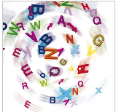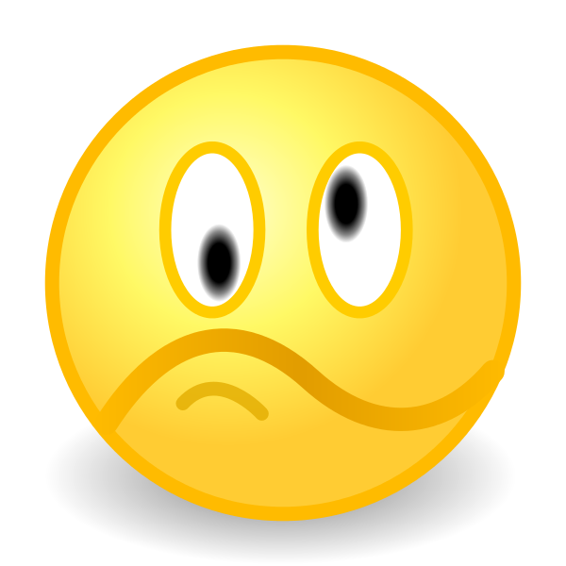
Read each lettered section, can you work out the order that each paragraph should go in?
Record below.
a)  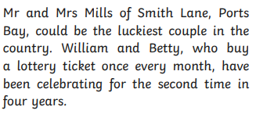 | e)  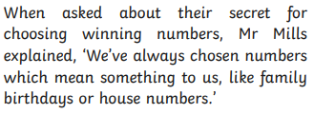
b)  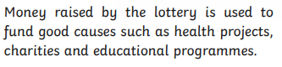 | f)  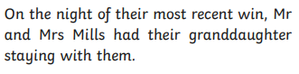
c)  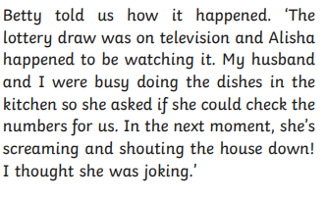 | g)  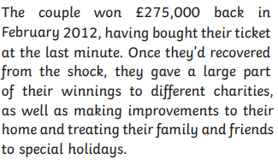
d)  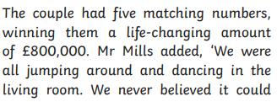  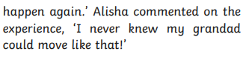 | h)  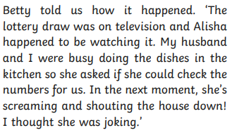

Order of paragraphs (beginning of the article to the end)
____ ____ ____ ____ ____ ____ ____ ____

Extension Activity
*Now that you have put the paragraphs in order can you create a headline for the article?
*What picture and caption would work well for the article. Draw and write one to go with the article.
Headline
Picture:

Caption:

