14.01.2021
L.I: To use methods of addition to solve problems.

As you have been practicing your expanded and compact column methods of addition, it is now time to put your skills to the test. Have a go at solving these problems to truly master your skill!

Activity 1)
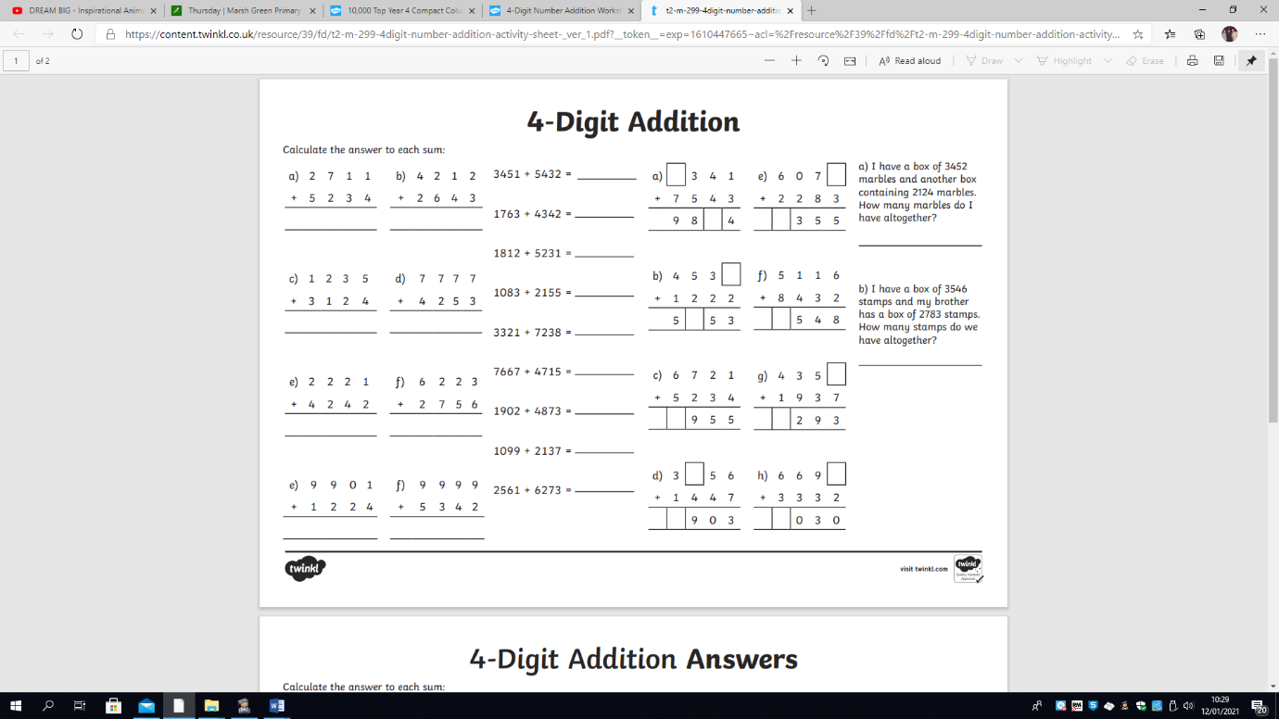

Activity 2) Activity 3)

Extension)

